**1. Introduction:**

Almost every new client these days wants a mobile version of their website. It’s practically essential after all: one design for the BlackBerry, another for the iPhone, the iPad, netbook, Kindle — and all screen resolutions must be compatible, too.

In the field of Web design and development, we’re quickly getting into the point of being unable to keep up with the endless new devices with their respective resolutions. For many websites, creating a different version for each resolution and new device would be impractical. Should we just suffer the consequences of losing visitors from one device for the benefit of gaining visitors from another? Or is there any other option?

**Responsive Web design** is the approach that suggests that design and development should respond to the user’s behavior and environment based on screen size, platform and orientation. The practice consists of a mix of flexible grids and layouts, images and an intelligent use of media queries. As the user switches from their laptop to iPad, the website should automatically switch to accommodate for resolution, image size and scripting abilities. In other words, the website should have the technology to automatically respond to the user’s preferences. This would eliminate the need for a different design and development phase for each new gadget on the market.

**1.1 Purpose:**

Responsive Web Design (RWD) essentially indicates that a web site is crafted to use Cascading Style Sheets 3 media queries, an extension of the @media rule, with fluid proportion-based grids (which use percentages and EMs instead of pixels), to adapt the layout to the viewing environment, and probably also use flexible images. As a result, users across a broad range of devices and browsers will have access to a single source of content, laid out so as to be easy to read and navigate with a minimum of resizing, panning, and scrolling.

**1.2 Scope:**

* The Responsive design for web pages will serve all sets of users having different Gadgets.
* The responsive web pages can be viewed from the smart phones having minimum of 320px screen width.
* The responsive web pages can be viewed from the Tablets having a minimum of 600px of screen width.
* Default CSS will be applied when the pages are viewed on laptop or desktop having a minimum screen width of 1024px.
* They are two orientations for all the devices Landscape view and portrait view.
* The Mobile version with Landscape view will have a minimum of 480px.
* The Tablet version with Landscape view will have a minimum of 760px.

**1.3 Definitions, Acronyms and Abbreviations:**

* **HTML (Hypertext markup language):** Hypertext Markup Language (HTML) is the main markup language for displaying web pages and other information that can be displayed in a web browser.
* **CSS (Cascading Style Sheets):** Cascading Style Sheets (CSS) is a style sheet language used for describing the presentation semantics (the look and formatting) of a document written in a markup language.
* **Media Queries**: A media query consists of a media type and zero or more expressions that check for the conditions of particular media features.
* **RWD (Responsive Web Design): It** is an approach that suggests that design and development should respond to the user’s behavior and environment based on screen size, platform and orientation.
* **HTTP (Hypertext Transfer Protocol):** It’s a service protocol.
* **PHP (Hypertext Preprocessor):** PHP is a general-purpose server-side scripting language originally designed for Web development to produce dynamic Web pages.
* **ASP (Active Server Pages):** Active Server Pages (ASP), also known as Classic ASP or ASP Classic, was Microsoft's first server-side script engine for dynamically generated web pages.

**1.4 Technologies to be used**

* **HTML 4.0:** Hypertext markup Language version 4.0.
* **CSS 2.1:** Cascading style sheets version 2.1.
* **PHP:** Hypertext preprocessor. It is a server side scripting language.
* **ASP:**  Active server pages. It is a server side scripting language.

**2. Literature Review**

In the introductory article about the Responsive Web Design approach, written by Ethan Marcotte, titled “Responsive Web Design - for A List Apart”, it stems from the notion of responsive architectural design, whereby a room or space automatically adjusts to the number and flow of people within it:

“Recently, an emerging discipline called “responsive architecture” has begun asking how physical spaces can respond to the presence of people passing through them. Through a combination of embedded robotics and tensile materials, architects are experimenting with art installations and wall structures that bend, flex, and expand as crowds approach them. Motion sensors can be paired with climate control systems to adjust a room’s temperature and ambient lighting as it fills with people. Companies have already produced “smart glass technology” that can automatically become opaque when a room’s occupants reach a certain density threshold, giving them an additional layer of privacy.”

Transplant this discipline onto Web design, and we have a similar and yet a whole new idea. Why should we create a custom Web design for each group of users; after all, architects don’t design a building for each group size and type that passes through it? Like responsive architecture, Web design should automatically adjust. It shouldn’t require countless custom-made solutions for each new category of users.

Obviously, we can’t use motion sensors and robotics to accomplish the way a building would. Responsive Web design requires a more abstract way of thinking. However, some ideas are already being practiced: fluid layouts, media queries and scripts that can reformat Web pages and mark-up effortlessly (or automatically).

But responsive Web design is not only about adjustable screen resolutions and automatically resizable images, but rather about a whole new way of thinking about design. Let’s talk about all of these features, plus additional ideas in the making.

**2.1 Adjusting Screen Resolution**

With more devices come varying screen resolutions, definitions and orientations. New devices with new screen sizes are being developed every day, and each of these devices may be able to handle variations in size, functionality and even color. Some are in landscape, others in portrait, still others even completely square. As we know from the rising popularity of the iPhone, iPad and advanced smart phones, many new devices are able to switch from portrait to landscape at the user’s whim as shown in figure-1. How is one to design for these situations?

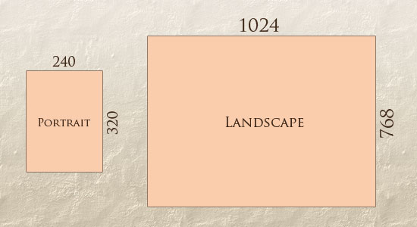

**Figure-1: Screen Orientations**

In addition to designing for both landscape and portrait (and enabling those orientations to possibly switch in an instant upon page load), we must consider the hundreds of different screen sizes (see figure-2). Yes, it is possible to group them into major categories, design for each of them, and make each design as flexible as necessary. But that can be overwhelming, and who knows what the usage figures will be in five years? Besides, many users do not maximize their browsers, which itself leaves far too much room for variety among screen sizes.

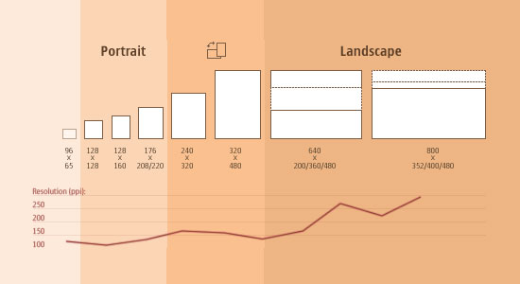

**Figure-2: Custom Screen Orientations**

Since then even more devices have come out. It’s obvious that we can’t keep creating custom solutions for each one. So, how do we deal with the situation?

**2.2 Part of the Solution: Flexible Everything:**

A few years ago, when flexible layouts were almost a “luxury” for websites, the only things that were flexible in a design were the layout columns (structural elements) and the text. Images could easily break layouts, and even flexible structural elements broke a layout’s form when pushed enough. Flexible designs weren’t really that flexible; they could give or take a few hundred pixels, but they often couldn’t adjust from a large computer screen to a netbook.

Now we can make things more flexible. Images can be automatically adjusted, and we have workarounds so that layouts never break (although they may become squished and illegible in the process). While it’s not a complete fix, the solution gives us far more options. It’s perfect for devices that switch from portrait orientation to landscape in an instant or for when users switch from a large computer screen to an iPad.

In Ethan Marcotte’s article, he created a sample Web design that features this better flexible layout as shown in figure-3:

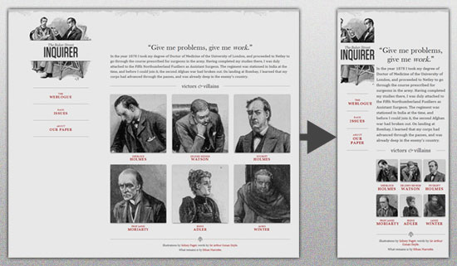

**Figure-3: Flexible Web Design Layout**

The entire design is a good mix of fluid grids, fluid images and smart mark-up where needed. Creating fluid grids is fairly a common practice, and there are a number of techniques for creating fluid images:

* Hiding and Revealing Portions of Images
* Creating Sliding Composite Images
* Foreground Images That Scale With the Layout

For more information on creating fluid websites, be sure to look at the book “Flexible Web Design: Creating Liquid and Elastic Layouts with CSS” by Zoe Mickley Gillenwater, and download the sample chapter “Creating Flexible Images.” In addition, Zoe provides the following extensive list of tutorials, resources, inspiration and best practices on creating flexible grids and layouts: “Essential Resources for Creating Liquid and Elastic Layouts.”

While from a technical perspective this is all easily possible, it’s not just about plugging these features in and being done. Look at the Figure-4 in this design, for example:

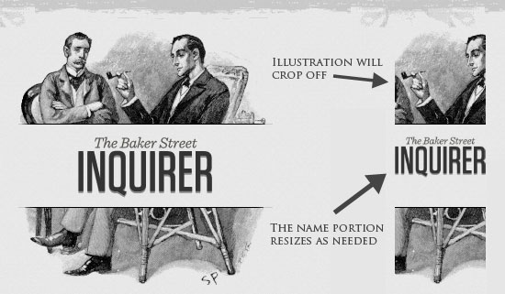

**Figure-4: A sample layout portraying the cropping of the image and resizing of the text.**

If resized too small, the image would appear to be of low quality, but keeping the name of the website visible and not cropping it off was important. So, the image is divided into two: one (of the illustration) set as a background, to be cropped and to maintain its size, and the other (of the name) resized proportionally.

***<h1 id="logo"><a href="#"><img src="site/logo.png" alt="The Baker Street Inquirer" /></a></h1>***

Above, the h1 element holds the illustration as a background, and the image is aligned according to the container’s background (the heading).

This is just one example of the kind of thinking that makes responsive Web design truly effective. But even with smart fixes like this, a layout can become too narrow or short to look right. In the logo example above (although it works), the ideal situation would be to not crop half of the illustration or to keep the logo from being so small that it becomes illegible and “floats” up.

**2.3 Flexible Images:**

One major problem that needs to be solved with responsive Web design is working with images. There are a number of techniques to resize images proportionately, and many are easily done. The most popular option, noted in Ethan Marcotte’s article on fluid images was first experimented by Richard Rutter, is to use CSS’s max-width for an easy fix.

***img { max-width: 100%; }***

As long as no other width-based image styles override this rule, every image will load in its original size, unless the viewing area becomes narrower than the image’s original width. The maximum width of the image is set to 100% of the screen or browser width, so when that 100% becomes narrower, so does the image. Essentially, as Jason Grigsby noted, “The idea behind fluid images is that you deliver images at the maximum size they will be used at. You don’t declare the height and width in your code, but instead let the browser resize the images as needed while using CSS to guide their relative size”. It’s a great and simple technique to resize images beautifully.

Note that max-width is not supported in IE, but a good use of width: 100% would solve the problem neatly in an IE-specific style sheet. One more issue is that when an image is resized too small in some older browsers in Windows, the rendering isn’t as clear as it ought to be. There is a JavaScript to fix this issue, though, found in Ethan Marcotte’s article.

While the above is a great quick fix and good start to responsive images, image resolution and download times should be the primary considerations. While resizing an image for mobile devices can be very simple, if the original image size is meant for large devices, it could significantly slow download times and take up space unnecessarily.

**2.4 Filament Group’s Responsive Images**

This technique, presented by the Filament Group, takes this issue into consideration and not only resizes images proportionately, but shrinks image resolution on smaller devices, so very large images don’t waste space unnecessarily on small screens. Check out the figure -5 below.

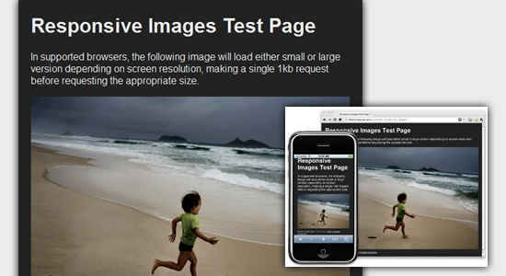

**Figure-5: example of a responsive image test page**

This technique requires a few files, all of which are available on Github. First, a JavaScript file (rwd-images.js), the .htaccess file and an image file (rwd.gif). Then, we can use just a bit of HTML to reference both the larger and smaller resolution images: first, the small image, with an .r prefix to clarify that it should be responsive, and then a reference to the bigger image using data-fullsrc.

***<img src="smallRes.jpg" data-fullsrc="largeRes.jpg">***

The data-fullsrc is a custom HTML5 attribute, defined in the files linked to above. For any screen that is wider than 480 pixels, the larger-resolution image (largeRes.jpg) will load; smaller screens wouldn’t need to load the bigger image, and so the smaller image (smallRes.jpg) will load.

The JavaScript file inserts a base element that allows the page to separate responsive images from others and redirects them as necessary. When the page loads, all files are rewritten to their original forms, and only the large or small images are loaded as necessary. With other techniques, all higher-resolution images would have had to be downloaded, even if the larger versions would never be used. Particularly for websites with a lot of images, this technique can be a great saver of bandwidth and loading time.

This technique is fully supported in modern browsers, such as IE8+, Safari, Chrome and Opera, as well as mobile devices that use these same browsers (iPad, iPhone, etc.). Older browsers and Firefox degrade nicely and still resize as one would expect of a responsive image, except that both resolutions are downloaded together, so the end benefit of saving space with this technique is void.

**2.5 Stop iPhone Simulator Image Resizing:**

One nice thing about the iPhone and iPod Touch is that Web designs automatically rescale to fit the tiny screen. A full-sized design, unless specified otherwise, would just shrink proportionally for the tiny browser, with no need for scrolling or a mobile version. Then, the user could easily zoom in and out as necessary.

There was, however, one issue this simulator created. When responsive Web design took off, many noticed that images were still changing proportionally with the page even if they were specifically made for (or could otherwise fit) the tiny screen. This in turn scaled down text and other elements as shown in figure-6.

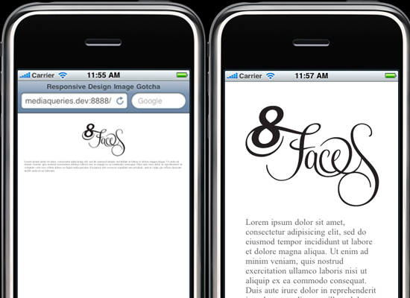

**Figure-6: Image scaling in smart phone**

Because this works only with Apple’s simulator, we can use an Apple-specific meta tag to fix the problem, placing it below the website’s <head> section. Thanks to Think Vitamin’s article on image resizing, we have the meta tag below:

***<meta name="viewport" content="width=device-width; initial-scale=1.0">***

Setting the initial-scale to 1 overrides the default to resize images proportionally, while leaving them as is if their width is the same as the device’s width (in either portrait or landscape mode). Apple’s documentation has a lot more information on the viewport meta tag.

**2.6 Custom Layout Structure:**

For extreme size changes, we may want to change the layout altogether, either through a separate style sheet or, more efficiently, through a CSS media query. This does not have to be troublesome; most of the styles can remain the same, while specific style sheets can inherit these styles and move elements around with floats, widths, heights and so on.

For example, we could have one main style sheet (which would also be the default) that would define all of the main structural elements, such as #wrapper, #content, #sidebar, #nav, along with colors, backgrounds and typography. Default flexible widths and floats could also be defined.

If a style sheet made the layout too narrow, short, wide or tall, we could then detect that and switch to a new style sheet. This new child style sheet would adopt everything from the default style sheet and then just redefine the layout’s structure.

/* Default styles that will carry to the child style sheet */

html,body{

background...

font...

color...

}

h1,h2,h3{}

p, blockquote, pre, code, ol, ul{}

/* Structural elements */

#wrapper{

width: 80%;

margin: 0 auto;

background: #fff;

padding: 20px;

}

#content{

width: 54%;

float: left;

margin-right: 3%;

}

#sidebar-left{

width: 20%;

float: left;

margin-right: 3%;

}

#sidebar-right{

width: 20%;

float: left;

}

Here is the mobile.css (child) content:

#wrapper{

width: 90%;

}

#content{

width: 100%;

}

#sidebar-left{

width: 100%;

clear: both;

/* Additional styling for our new layout */

border-top: 1px solid #ccc;

margin-top: 20px;

}

#sidebar-right{

width: 100%;

clear: both;

/* Additional styling for our new layout */

border-top: 1px solid #ccc;

margin-top: 20px;

}

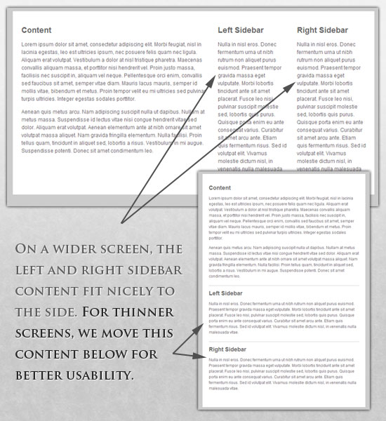

**Figure-7: Customization of Layouts**

**2.7 Media Queries:**

Above are a few examples of how media queries, both from CSS 2.1 and CSS3 could work. Let’s now look at some specific how-to’s for using CSS3 media queries to create responsive Web designs. Many of these uses are relevant today, and all will definitely be usable in the near future.

The min-width and max-width properties do exactly what they suggest. The min-width property sets a minimum browser or screen width that a certain set of styles (or separate style sheet) would apply to. If anything is below this limit, the style sheet link or styles will be ignored. The max-width property does just the opposite. Anything above the maximum browser or screen width specified would not apply to the respective media query.

Note in the examples below that we’re using the syntax for media queries that could be used all in one style sheet. As mentioned above, the most efficient way to use media queries is to place them all in one CSS style sheet, with the rest of the styles for the website. This way, multiple requests don’t have to be made for multiple style sheets.

***@media screen and (min-width: 600px) {***

***.hereIsMyClass {***

***width: 30%;***

***float: right;***

***}***

***}***

The class specified in the media query above (hereIsMyClass) will work only if the browser or screen width is above 600 pixels. In other words, this media query will run only if the minimum width is 600 pixels (therefore, 600 pixels or wider).

***@media screen and (max-width: 600px) {***

***.aClassforSmallScreens {***

***clear: both;***

***font-size: 1.3em;***

***}***

***}***

Now, with the use of max-width, this media query will apply only to browser or screen widths with a maximum width of 600 pixels or narrower.

While the above min-width and max-width can apply to either screen size or browser width, sometimes we’d like a media query that is relevant to device width specifically. This means that even if a browser or other viewing area is minimized to something smaller, the media query would still apply to the size of the actual device. The min-device-width and max-device-width media query properties are great for targeting certain devices with set dimensions, without applying the same styles to other screen sizes in a browser that mimics the device’s size.

***@media screen and (max-device-width: 480px) {***

***.classForiPhoneDisplay {***

***font-size: 1.2em;***

***} }***

***@media screen and (min-device-width: 768px) {***

***.minimumiPadWidth {***

***clear: both;***

***margin-bottom: 2px solid #ccc;***

***}***

***}***

There are also other tricks with media queries to target specific devices. Thomas Maier has written two short snippets and explanations for targeting the iPhone and iPad only:

CSS for iPhone 4 (Retina display)

How To: CSS for the iPad

For the iPad specifically, there is also a media query property called orientation. The value can be either landscape (horizontal orientation) or portrait (vertical orientation).

***@media screen and (orientation: landscape) {***

***.iPadLandscape {***

***width: 30%;***

***float: right;***

***}***

***}***

***@media screen and (orientation: portrait) {***

***.iPadPortrait {***

***clear: both;***

***}***

***}***

Unfortunately, this property works only on the iPad. When determining the orientation for the iPhone and other devices, the use of max-device-width and min-device-width should do the trick.

There are also many media queries that make sense when combined. For example, the min-width and max-width media queries are combined all the time to set a style specific to a certain range.

***@media screen and (min-width: 800px) and (max-width: 1200px) {***

***.classForaMediumScreen {***

***background: #cc0000;***

***width: 30%;***

***float: right;***

***}***

***}***

The above code in this media query applies only to screen and browser widths between 800 and 1200 pixels. A good use of this technique is to show certain content or entire sidebars in a layout depending on how much horizontal space is available.

Some designers would also prefer to link to a separate style sheet for certain media queries, which is perfectly fine if the organizational benefits outweigh the efficiency lost. For devices that do not switch orientation or for screens whose browser width cannot be changed manually, using a separate style sheet should be fine.

You might want, for example, to place media queries all in one style sheet (as above) for devices like the iPad. Because such a device can switch from portrait to landscape in an instant, if these two media queries were placed in separate style sheets, the website would have to call each style sheet file every time the user switched orientations. Placing a media query for both the horizontal and vertical orientations of the iPad in the same style sheet file would be far more efficient.

Another example is a flexible design meant for a standard computer screen with a resizable browser. If the browser can be manually resized, placing all variable media queries in one style sheet would be best.

Nevertheless, organization can be key, and a designer may wish to define media queries in a standard HTML link tag:

***<link rel="stylesheet" media="screen and (max-width: 600px)" href="small.css" />***

***<link rel="stylesheet" media="screen and (min-width: 600px)" href="large.css" />***

***<link rel="stylesheet" media="print" href="print.css" />***

**2.8 Introduction to media types**

One of the most important features of style sheets is that they specify how a document is to be presented on different media: on the screen, on paper, with a speech synthesizer, with a braille device, etc.

Certain CSS properties are only designed for certain media (e.g., the 'page-break-before' property only applies to paged media). On occasion, however, style sheets for different media types may share a property, but require different values for that property. For example, the 'font-size' property is useful both for screen and print media. The two media types are different enough to require different values for the common property; a document will typically need a larger font on a computer screen than on paper. Therefore, it is necessary to express that a style sheet, or a section of a style sheet, applies to certain media types.

**2.9 Specifying media-dependent style sheets**

There are currently two ways to specify media dependencies for style sheets:

Specify the target medium from a style sheet with the @media or @import at-rules.

***@import url("fancyfonts.css") screen;***

***@media print {***

***/* style sheet for print goes here */***

***}***

Specify the target medium within the document language. For example, in HTML 4 ([HTML4]), the "media" attribute on the LINK element specifies the target media of an external style sheet:

***<!DOCTYPE HTML PUBLIC "-//W3C//DTD HTML 4.01//EN">***

***<HTML>***

***<HEAD>***

***<TITLE>Link to a target medium</TITLE>***

***<LINK REL="stylesheet" TYPE="text/css"***

***MEDIA="print, handheld" HREF="foo.css">***

***</HEAD>***

***<BODY>***

***<P>The body...***

***</BODY>***

***</HTML>***

The @import rule is defined in the chapter on the cascade.

**2.10 The @media rule:**

An @media rule specifies the target media types (separated by commas) of a set of statements (delimited by curly braces). Invalid statements must be ignored per 4.1.7 "Rule sets, declaration blocks, and selectors" and 4.2 "Rules for handling parsing errors." The @media construct allows style sheet rules for various media in the same style sheet:

***@media print {***

***body { font-size: 10pt }***

***}***

***@media screen {***

***body { font-size: 13px }***

***}***

***@media screen, print {***

***body { line-height: 1.2 }***

***}***

Style rules outside of @media rules apply to all media types that the style sheet applies to. At-rules inside @media are invalid in CSS2.1.

**2.11 Recognized media types**

The names chosen for CSS media types reflect target devices for which the relevant properties make sense. In the following list of CSS media types the names of media types are normative, but the descriptions are informative. Likewise, the "Media" field in the description of each property is informative.

* **All**: Suitable for all devices.
* **Braille**: Intended for braille tactile feedback devices.
* **Embossed**: Intended for paged braille printers.
* **Handheld**: Intended for handheld devices (typically small screen, limited bandwidth).
* **Print**: Intended for paged material and for documents viewed on screen in print preview mode. Please consult the section on paged media for information about formatting issues that are specific to paged media.
* **Projection**: Intended for projected presentations, for example projectors. Please consult the section on paged media for information about formatting issues that are specific to paged media.
* **Screen**: Intended primarily for color computer screens.
* **Speech**: Intended for speech synthesizers. Note: CSS2 had a similar media type called 'aural' for this purpose. See the appendix on aural style sheets for details.
* **Tty**: Intended for media using a fixed-pitch character grid (such as teletypes, terminals, or portable devices with limited display capabilities). Authors should not use pixel units with the "tty" media type.
* **TV**: Intended for television-type devices (low resolution, color, limited-scrollability screens, and sound available).

**2.12 Media type names are case-insensitive:**

Media types are mutually exclusive in the sense that a user agent can only support one media type when rendering a document. However, user agents may use different media types on different canvases. For example, a document may (simultaneously) be shown in 'screen' mode on one canvas and 'print' mode on another canvas.

Note that a multimodal media type is still only one media type. The 'tv' media type, for example, is a multimodal media type that renders both visually and aurally to a single canvas.

@media and @import rules with unknown media types (that are nonetheless valid identifiers) are treated as if the unknown media types are not present. If an @media/@import rule contains a malformed media type (not an identifier) then the statement is invalid.

Note: Media Queries supersedes this error handling.

For example, in the following snippet, the rule on the P element applies in 'screen' mode (even though the '3D' media type is not known).

***@media screen, 3D {***

***P { color: green; }***

***}***

Note. Future updates of CSS may extend the list of media types. Authors should not rely on media type names that are not yet defined by a CSS specification.

**2.13 Media groups**

This section is informative, not normative.

Each CSS property definition specifies which media types the property applies to. Since properties generally apply to several media types, the "Applies to media" section of each property definition lists media groups rather than individual media types. Each property applies to all media types in the media groups listed in its definition.

CSS 2.1 defines the following media groups:

* continuous or paged.
* visual, audio, speech, or tactile.
* grid (for character grid devices), or bitmap.
* interactive (for devices that allow user interaction), or static (for those that do not).
* all (includes all media types)

**2.14 Showing or Hiding the content:**

It is possible to shrink things proportionally and rearrange elements as necessary to make everything fit (reasonably well) as a screen gets smaller. It’s great that that’s possible, but making every piece of content from a large screen available on a smaller screen or mobile device isn’t always the best answer. We have best practices for mobile environments: simpler navigation, more focused content, lists or rows instead of multiple columns.

Responsive Web design shouldn’t be just about how to create a flexible layout on a wide range of platforms and screen sizes. It should also be about the user being able to pick and choose content. Fortunately, CSS has been allowing us to show and hide content with ease for years!

***display: none;***

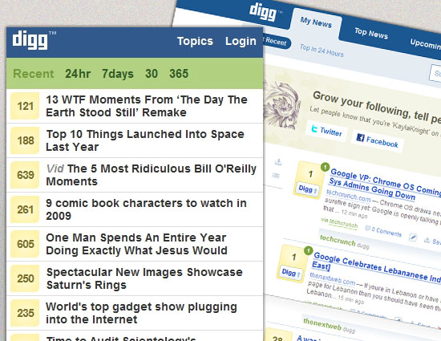

**Figure-8: Example of Responsive Web Design**

  Either declare display: none for the HTML block element that needs to be hidden in a specific style sheet or detect the browser width and do it through JavaScript. In addition to hiding content on smaller screens, we can also hide content in our default style sheet (for bigger screens) that should be available only in mobile versions or on smaller devices. For example, as we hide major pieces of content, we could replace them with navigation to that content, or with a different navigation structure altogether as shown in figure-8.

Note that we haven’t used visibility: hidden here; this just hides the content (although it is still there), whereas the display property gets rid of it altogether. For smaller devices, there is no need to keep the mark-up on the page — it just takes up resources and might even cause unnecessary scrolling or break the layout see figure-9.

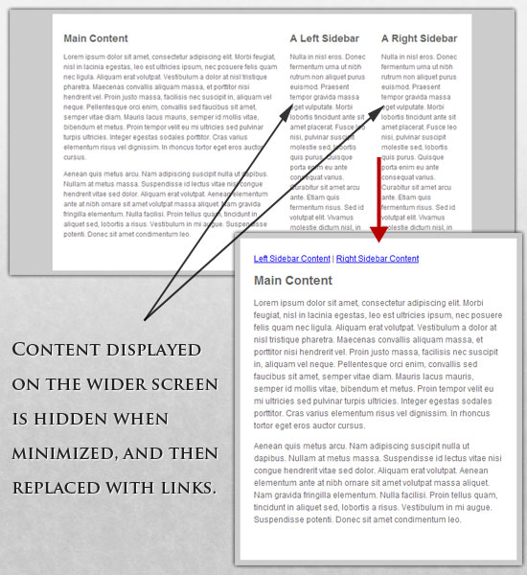

**Figure-9: Screen Enhancements**

**Here is our mark-up:**

***<p class="sidebar-nav"><a href="#">Left Sidebar Content</a> | <a href="#">Right Sidebar Content</a></p>***

***<div id="content">***

***<h2>Main Content</h2>***

***</div>***

***<div id="sidebar-left">***

***<h2>A Left Sidebar</h2>***

***</div>***

***<div id="sidebar-right">***

***<h2>A Right Sidebar</h2>***

***</div>***

In our default style sheet below, we have hidden the links to the sidebar content. Because our screen is large enough, we can display this content on page load.

Here is the style.css (default) content:

***#content{***

***width: 54%;***

***float: left;***

***margin-right: 3%;***

***}***

***#sidebar-left{***

***width: 20%;***

***float: left;***

***margin-right: 3%;***

***}***

***#sidebar-right{***

***width: 20%;***

***float: left;***

***}***

***.sidebar-nav{display: none;}***

Now, we hide the two sidebars (below) and show the links to these pieces of content. As an alternative, the links could call to JavaScript to just cancel out the display: none when clicked, and the sidebars could be realigned in the CSS to float below the content (or in another reasonable way).

Here is the mobile.css (simpler) content:

***#content{***

***width: 100%;***

***}***

***#sidebar-left{***

***display: none;***

***}***

***#sidebar-right{***

***display: none;***

***}***

***.sidebar-nav{display: inline;}***

With the ability to easily show and hide content, rearrange layout elements and automatically resize images, form elements and more, a design can be transformed to fit a huge variety of screen sizes and device types. As the screen gets smaller, rearrange elements to fit mobile guidelines; for example, use a script or alternate style sheet to increase white space or to replace image navigation sources on mobile devices for better usability (icons would be more beneficial on smaller screens).

**3. Problem Specification**

**3.1 Proposed System:**

The main objective is to customize and integrate a website into smart phones and tablets in such a way that the browser generates responses depending upon the device used by the users. This approach optimizes the web page contents in such a way that gives the best look and feel experience to the users basing upon the device being used by the users.

**3.2Methodology:**

The plan is to apply responsive web design to GITAM UNIVERSITY official website [www.gitam.edu](http://www.gitam.edu). This technology will customize the web pages into all suitable gadgets like mobile phones, tablets, or laptops and responds to the user’s behavior and environment based on screen size, platform and orientation. As the user switches from their laptop to tablet, the website will automatically switch to accommodate for resolution, image size and scripting abilities. In other words, the website will automatically respond to the user’s preferences. This would eliminate the need for a different design and development phase for each new gadget on the market.

As a part of this, we have divided the entire project into two phases.

* **First Phase:** In the First Phase the problem was identified, and the scope and extent was defined. An SRS (Software Requirement Specification) document stating the design and implementation methodologies along with the system model was prepared.
* **Second Phase:** During this phase, the responsive design to the entire website right from the home page (<http://www.gitam.edu>) will be developed.

**4. Software Requirement Specification**

**4.1 Software Interface:**

**4.1.1 Minimum Configuration**

**At Client Side:**

|  |  |  |
| --- | --- | --- |
| **Browser** | **Version** | **Operating System** |
| Internet Explorer | 5.5 | Windows |
| Firefox | 2.0 | --Any-- |
| Chrome | 4.0 | --Any-- |
| Safari | 3.1 | ios ,windows |
| Opera | 9.0 | --Any— |
| Opera Mini | 5.0 | --Any Mobile os-- |
| Opera Mobile | 10.0 | --Any Mobile os-- |
| Android Browser | 2.1 | Android |

**At Server Side:**

|  |  |  |  |
| --- | --- | --- | --- |
| **Web Server** | **Server Version** | **Operating System** | **OS Version** |
| Internet Information Services(IIS) | 1.0 | Windows | Windows NT 3.51 |
| Apache | 2.0 | Windows or Linux | --Any-- |

**4.1.2 Recommended Configuration**

**At Client Side:**

|  |  |  |
| --- | --- | --- |
| **Browser** | **Version** | **Operating System** |
| Internet Explorer | 9.0 | Windows |
| Firefox | 10.0 | --Any-- |
| Chrome | 17.0 | --Any-- |
| Safari | 5.1 | ios ,windows |
| Opera | 11.6 | --Any— |
| Opera Mini | 5.0 | --Any Mobile os-- |
| Opera Mobile | 11.5 | --Any Mobile os-- |
| Android Browser | 4.0 | Android |

**At Server Side:**

|  |  |  |  |
| --- | --- | --- | --- |
| **Web Server** | **Server Version** | **Operating System** | **OS Version** |
| Internet Information Services(IIS) | 7.0 | Windows | Windows NT 3.51 |
| Apache | 2.4 | --Any-- | --Any-- |

**4.2 Hardware Interface**

**4.2.1 Minimum Configuration**

**At Client Side**

|  |  |  |  |
| --- | --- | --- | --- |
| **Device** | **CPU** | **RAM** | **Resolution** |
| Desktop | 800 MHz | 128 MB | 1024 X 768 |
| Tablet | 0.3 GHz | 512 MB | 600 X 760 |
| Mobile | 412 MHz | 128 MB | 320 X 480 |

**At Server Side**

|  |  |  |
| --- | --- | --- |
| **Processor** | **RAM** | **Disk Space** |
| Intel Pentium III or AMD-800Mhz | 1GB | 80GB |

**4.2.2 Recommended Configuration**

**At Client Side**

|  |  |  |  |
| --- | --- | --- | --- |
| **Device** | **CPU** | **RAM** | **Resolution** |
| Desktop | 2.3 GHz | 2 GB | 1024 X 768 |
| Tablet | 1 GHz | 1 GB | 600 X 760 |
| Mobile | 1 GHz | 512 MB | 320 X 480 |

**At Server Side**

|  |  |  |
| --- | --- | --- |
| **Processor** | **RAM** | **Disk Space** |
| Intel I5 2nd generation | 8GB | 700 GB |

**4.3 Product function:**

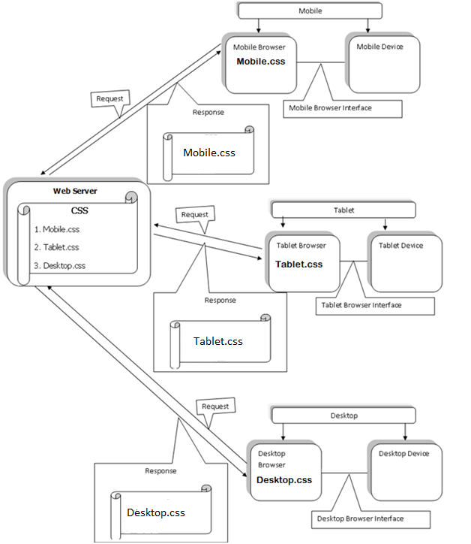

**Figure-10: Product Function**

**4.4 User Characteristics:**

We have identified five potential classifications of users of our system:

* **Web Designers:** These are the most obvious users. They will use the system as a means of laying out the design of an as yet unimplemented system.
* **Web Developers:** These are the people that take the model generated by the designers and implement it in code. They may also use the system to identify the design of an existing system in order to maintain it.
* **Quality Engineers:** These users are usually responsible for ensuring that a design is feasible and/or reliable. They will therefore also need to be looking at the output from our system.
* **System Administrator:** Due to the client/server/concurrent nature of the system, someone needs to be responsible for security and maintenance of the system. This is the System Administrators role. The Administrator of the system, project or model need not be a member of the any of the other roles identified here.
* **The Client:** More often than not, website is designed for a client. The client may wish to see the design as layout by the system and be able to see what exactly they are buying.
* **The General User:** Now-a-days every user is using their Smartphone’s and tablets with high internet connectivity. So this makes their life simpler and easy to access any website through their handheld devices. So the website should have responsive designs applied so that the response generated to that particular device may get customized depending upon the screen resolution and type of the device. They may be three categories of users
  + - **Mobile Users:** The users using their smart phones with a minimum screen width of 320px can view the webpage’s in two different orientations, portrait and Landscape view. When the device is rotated horizontally the screen width becomes 480px called as Landscape view and the webpage contents adjust themselves to fit the best way possible in the available viewport of 480px.
    - **Tablet Users:** The users using their tablets with a minimum screen width of 600px can view the webpage’s in two different orientations, portrait and Landscape view. When the device is rotated horizontally the screen becomes 760px called Landscape view and the webpage contents adjust themselves to fit the best way possible in the available viewport of 760px.
    - **Desktop/Laptop User:** The Desktop or the Laptop has a minimum of 1024px screen resolution. Generally the CSS is written for 1024px screen resolution and it is customized for all the other device screen resolutions depending upon their viewport. If the device is not able to detect the media queries then it will apply the default desktop version css in to their device browser.

**4.5 Constraints**

* This Website can be viewed from all the devices like Mobiles, Tablet, Laptop and Desktop.
* Every Device will have their own design for the webpage.
* The browsers that detect media queries should only be used as the device browsers.
* Limited to HTTP/HTTPS
* The webpage’s will be deployed in the public web server that can be accessed from anywhere around the world from any device.

**4.6 Architecture Design**

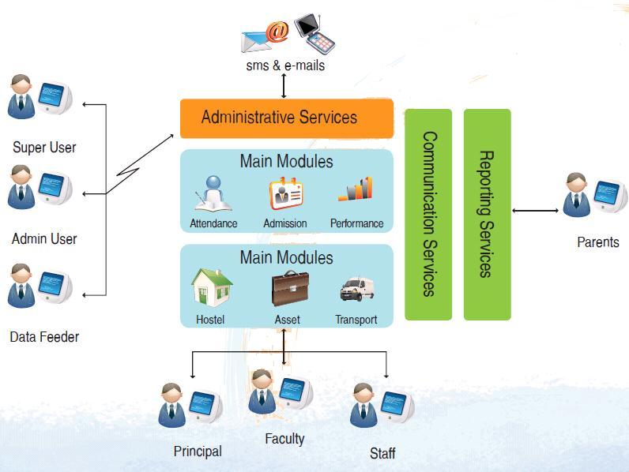

**Figure-11: architectural Design**

**4.7 Responsive Design Process Model**

Every project, big or small, goes through some software engineering Process. We call it the four Ds: discovery, design, development, and deployment. We tie all of this together to form our responsive web design process. The deliverables for your project might vary, but here's an idea of what you can expect from us.

**Discovery**

**1. Kickoff & Project Charter**

First things first: meet up and get to know each other. From our early meetings and research, we'll establish communication protocols, milestones and timelines, deliverables and scope, roles and expectations.

**2. Project Analysis**

We will work to determine the requirements of the project, from a technical, creative, and organizational perspective. We’ll analyze content, writing style, visual design, and interface design, and make sure we understand everything there is to know about your industry. Our project analysis will guide us in understanding where your organization has been, what it is currently doing, and where it wants to go in the future. This guides us in tailoring a solution that is effective and sustainable. We will also spend time getting to really understand your brand by analyzing past and present marketing materials, discussing future marketing strategies, and aligning them with your web project.

**3. Content Strategy**

Using the knowledge gained from our discovery conversations, we will audit existing content both quantitatively and qualitatively. What exists on your current site? And, more importantly, is it doing what you need it to do? We'll create a site map for your project and show where everything belongs. This process will inform what and how we communicate, and establish the features your users need. Well-planned, well-structured content will help us create both the interaction and visual design systems.

**4. Search Strategy**

We'll develop a document summarizing best practices for Search Engine Optimization, including page structure, URL syntax, meta data, and content hierarchy.

**5. Strategic Direction**

All of the information found during the discovery phase will be complied into a concise document that outlines the search, content, technical, and creative strategies. This document will act as the project map, keeping all team members in line with a focused strategy.

**Design**

**6. UX Sketches**

We will work with you through an iterative process to create rough wireframes, or UX sketches, for key views. This will help establish the design system, while communicating a sense of the functionality. This is also where we decide on the break points for the responsive design.

**7. Page Tables**

One of our main goals is to keep content independent from design or presentation. Your content should never be dependent on a layout to work properly. So, along with wireframes, you will receive a set of page tables for key content pages. Page tables identify each content area in priority order, and identify the most important messages to communicate in each area.

**8. Interaction Design**

Once we all agree on where we’re headed, we’ll wireframe and document the remaining views, with the functionalities established by the page tables and feature list. Each and every view scenario will be documented to visualize all the content and features we’ve planned. Along with that we’ll create rough greybox HTML prototypes to demonstrate responsive interaction patterns.

**9. Visual Design**

With functionality fully documented in the wireframes, we’ll layer in the branding elements, color palettes, and typography that give each site its unique look and feel. Through an iterative process between our team and yours, we’ll make all the big decisions about typographic hierarchy, vertical rhythm, and interface details. We can create static visual mockups, browser-based prototypes, or both.

**10. Style guide / Documentation**

Next, we’ll create a style guide that will document the design system so that they can be properly implemented. All the details from the grid to hover/touch states to typography styles to content messaging will be detailed. This guide will demonstrate the design thinking and personality of the system. Depending on the complexity of the site, this could be created in an interface harmony canvas.

**Develop**

**11. HTML or Theme Build**

Now it’s time to get down to business and build HTML/CSS/JavaScript themes: functional, browser-tested, HTML pages ready for testing. We’ll make sure all content is governed by CSS and meets W3C standards. We’ll use JavaScript for interactive elements, rather than Flash or Silver light. We’ll also help you adhere to best practices for online readability, and include a print CSS for readers that want to print out your content.

**12. CMS Build & Template Implementation**

At this stage, the technical architecture will be built out on a system like Open Text Web Site Management depending on your organization’s needs. We’ll build out all of the site’s modular elements and e‐commerce components, and set up a workflow process that will help you maintain your content over the long term. This process goes hand-in-hand with the CMS Template Implementation, which will integrate the HTML templates into the design or theme layer.

**13. Cross-Browser/Device Testing**

Here's where we test and demonstrate how page templates will render in major web browsers and mobile devices (i.e. iPad, iPhone, Blackberry, Android, etc). It is important to understand that the design will be appropriate for each device, but may be slightly different due to device specs and experience. It’s not about making everything look the same, it’s about creating a coherent experience across all devices.

**Deploy**

**14. Content Migration**

Depending on your organization’s needs, and our audit of your current website, we’ll help you define the scope of the content migration phase. As we all know, a website without content is a black hole of sadness.

**15. User Acceptance Testing**

User Acceptance Testing (UAT) helps us confirm that your new site meets the objectives and requirements we defined early in the project. This also involves taking the users feedback, comments and suggestions.

**16. Documentation & Training**

We will prepare text and video documentation on to help you understand and use your new CMS and site. We will generally provide a period of user acceptance testing following the official “handoff” of the website, to make absolutely sure that everything meets your needs. We’ll also provide additional support and training where necessary, and take care of any bug fixes to make sure that your website is ready for launch.

**17. Launch Plan & Release**

We will create a launch plan to archive the current website (if needed) and release the new website to the public, as well as a quality checklist to ensure that all project requirements are met. We’ll make sure that the new website is submitted to the appropriate search engines, and that web analytics are installed and configured

**5. System analysis**

**5.1 Existing System:** The Existing GITAM UNIVERSITY official website has no responsive design applied for it. Hence when a user hits the url of the website from their devices the normal desktop version of css will be loaded into their devices.

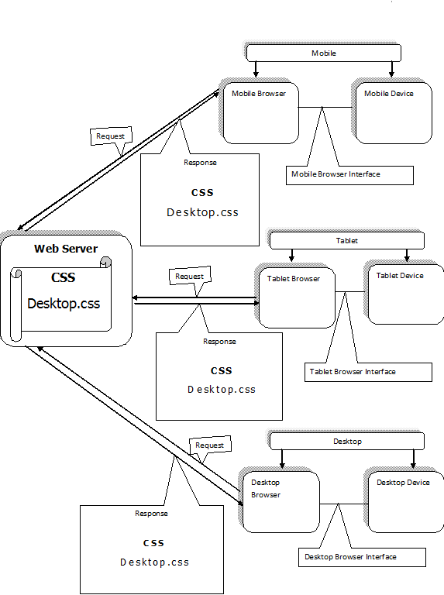

**Figure-12: Present Scenario**

**5.2 Proposed System:** The new system that is proposed will apply responsive design for the Gitam web pages such that they customize their view automatically depending upon the device screen resolutions which gives good look and feel experience.



**Figure-13**: **Proposed System with Desired Changes**

**6. System Design**

**6.1 Use case Diagram**

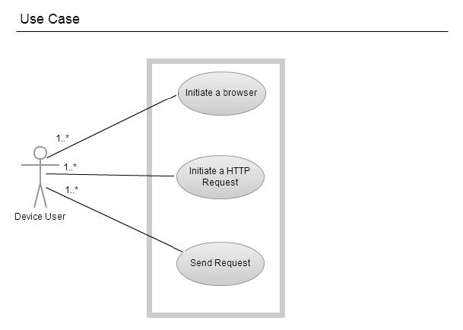

**Figure-14: Use case diagram**

**Use Case Diagram:**

The above shown diagram is a use case diagram representing the scenario of a device user. The device user can be either a mobile user or a tablet user or a desktop user. The following are some of the user scenarios.

* The device user initiates a browser.
* The device user initiates an http request.
* The device user sends a request.

**6.2 Activity Diagram**

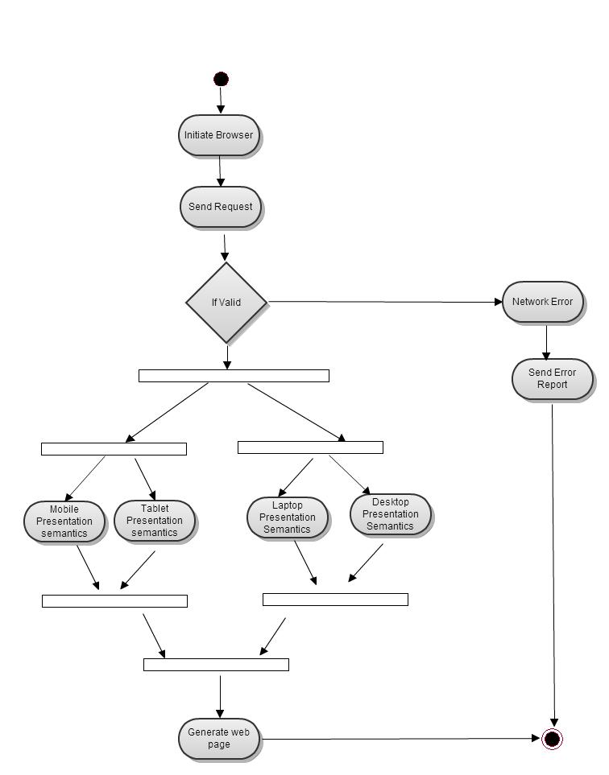

**Figure-15: Activity diagram**

**Description:**

The above diagram is an activity diagram representing the following activity flow.

**Step 1:**  The user initiates the browser.

**Step 2:**  The browser send requests to the server for the required page and calls the appropriate css file basing on the device screen resolution.

**Step 3:** The sent request is validated.

**Step 3.1:**  If it is an invalid request then the server sends back an error report.

**Step 3.2:** If it is a valid request then the response is sent to the device

**Step 4:** The obtained response is displayed by the device browser.

**6.3 State chart Diagram**

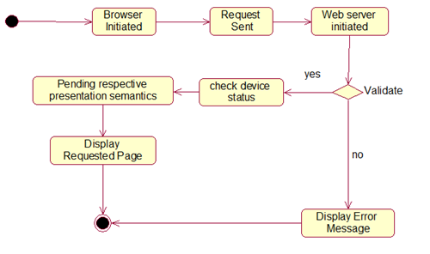

**Figure-16: State chart diagram**

**Description:**

The browser of the respective device is initiated by the user for the purpose of requesting a webpage. The browser sends the request to the web server, by which it is initiated. The server then validates the request. If the request is invalid then it sends an error response to the browser stating that the request is invalid. If the request is a valid one then it checks for the device status and chooses respective presentation semantics. Finally it displays the required web page.

The following are the states and their flow of control.

* **Browser Initiated:**  The browser is first initiated.
* **Request Sent:** The required web page is requested from the browser.
* **Web server initiated:** The web server gets initiated by receiving the request and it validates the request, if invalid it sends the error message.
* **Check device status:** The device status is checked.
* **Pending Presenting semantics:** The presentation semantics are pending.
* **Display requested page**: Displays the requested page.
* **Display Error message**: The error messages are displayed.

**6.4 Sequence Diagram**

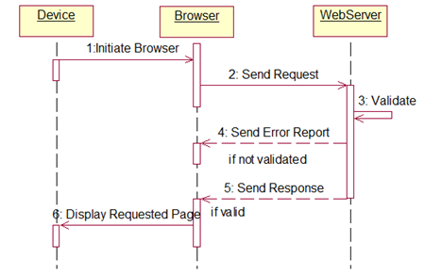

**Figure-17: Sequence Diagram**

**Description:**

The above diagram is a sequence diagram representing the sequential flow of messages.

**Step 1:** Initiate the browser from the respective device.

**Step 2:** Send request from the browser to the web server.

**Step 3:** Validate the request in the web server.

**Step 4:** If invalid send the report error.

**Step 5:** If valid, send the respective response.

**Step 6:** Display the requested page.

**6.5 Collaboration Diagram**

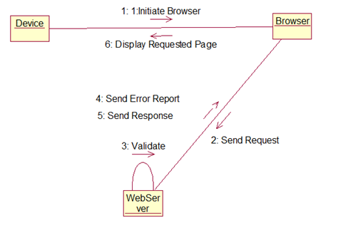

**Figure-18: Collaboration Diagram**

**Description:**

The collaboration diagram shows the actual objects and their links. It represents the structural orientation of the objects. It consists of three objects namely device, browser and web server.

**Step 1:** Initiate the browser from the respective device.

**Step 2:** Send request from the browser to the web server.

**Step 3:** Validate the request in the web server.

**Step 4:** If invalid send the report error.

**Step 5:** If valid, send the respective response.

**Step 6:** Display the requested page.

**6.6 Component Diagram**

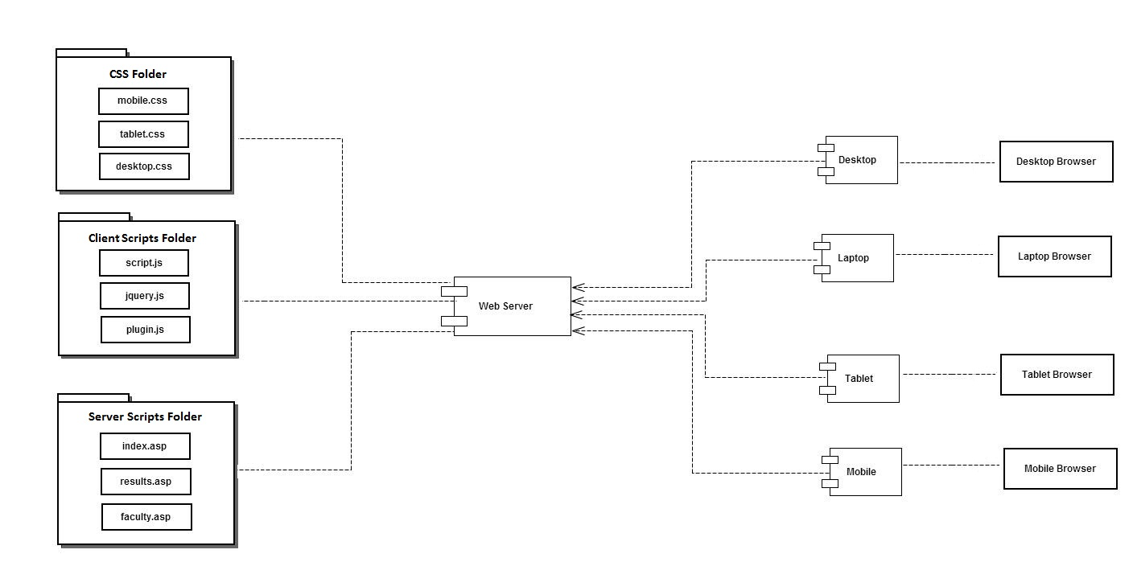

**Figure-19: Component diagram**

**Description:**

The above diagram shows all the components and their relationships. The components of this system are desktop, laptop, tablet, mobile and web server. The web server component having hierarchical directory structure consists of three directories namely css directory which consists of css files, client side scripting directory which consist of JavaScript files, server side scripting directory which consists of server side source files. The component Desktop uses a sub component program called desktop browser to communicate with the web server.

**6.7 Deployment Diagram:**

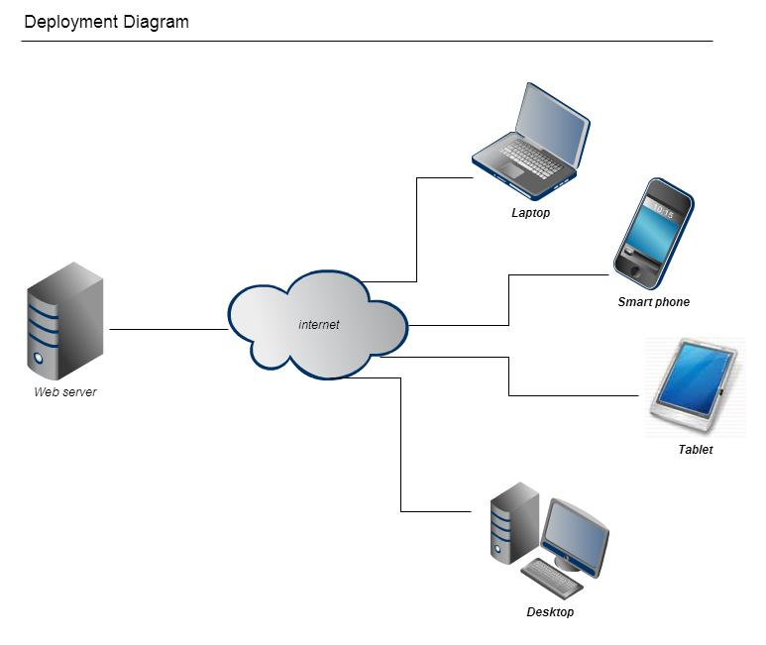

**Figure-20: Deployment diagram**

**Description:**

Show the physical deployment of the hardware and software of the system. The main components of the system are web server, laptop, internet and desktop.

**Web server**: It is a component which generates responses basing on the users requests

**Internet**: It is a physical connection of all the network devices and components.

**Desktop**: It is a device which has a minimum screen resolution of 1024 × 768px or more.

**Laptop**: It is a device which has a minimum screen resolution of 1024 × 768px.

**Tablet:** It is a device which has a minimum screen resolution of 600 × 600px.

**Smart Phone:** It is a device which has a minimum screen resolution of 320 × 600px.

**7.0 Coding**

Responsive web design is applied to Gitam university web portal home page bearing url <http://www.gitam.edu>.

**Steps for a responsive page:**

* **Code Clean up**
* **Meta tag definition**
  + **Configures viewport**
* **Folder Hierarchy**
* **Modifying html structure layout**
  + **Adding adaptive grids and images.**
  + **Applying display and visibility properties in the css.**
* **Media queries**
  + **Adds conditional clauses to generate external style sheet responses depending on the device screen resolution.**
* **Desktop Layout**
* **Tablet Layout**
* **Mobile Layout**

**7.1 Code cleanup:**

The code cleanup stage cleans the code and enhances the code in such a way that it meets all the html standards. The deprecated tags are eliminated according to the version of html used. Some of the new tags that are added in the current version are also added so that the entire source files come under one set of standards and specifications. The inline style specification should be removed and they should be specified in an external css file document which is linked to this document by identifying the tag by an id or a class. Some of the unnecessary tags should be removed and heavy nesting of tags should be reduced. A proper indentation should be maintained so that the code looks neat and understandable.

**7.2 Meta tag definition:**

Metadata is data about data. The <meta> tag provides metadata about the HTML document.

Meta elements are typically used to specify page description, keywords, author of the document, last modified and other metadata. It can be used by browsers (how to display content or reload page), search engines (keywords), or other web services. Here we use meta tag to configure our view port. Viewport is a canvass that sets the width to a desired device width and hence sets the page dimensions. The viewport meta tag is used to prepare a page for device optimization. Therefore the following line of code is to be inserted inside the head tag of the html page.

<meta name="viewport" content="width=device-width" />

The meta tag defines a viewport and sets its content attribute ‘width’ to the device width. Here the device width refers to the width of the device with which the request for this page is made to the web server.

**7.3 Folder hierarchy:**

We have to maintain a folder hierarchy for easy understandability and flexibility. We used visual web developer IDE for coding. Therefore a screenshot of the folder hierarchy is displayed which clearly segregates the different css files, control files, master files, main source files and property files.

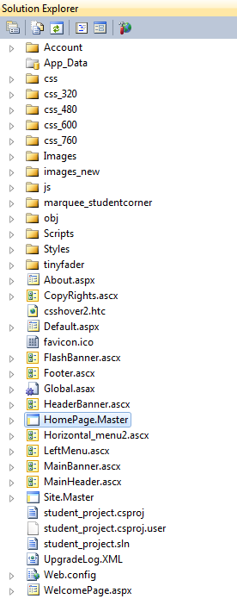

**Figure-21: Folder Hierarchy**

It clearly shows the different folder assignment for different css files.

* Css_320 folder contains all the css files written for mobile devices which have a minimum screen resolution of 320px width.
* Css_480 folder contains all the css files written for mobile devices which have a minimum screen resolution of 480px width.
* Css_600 folder contains all the css files written for tablet devices which have a minimum screen resolution of 600px width.
* Css_760 folder contains all the css files written for table devices which have a minimum screen resolution of 760px width.
* Css folder contains all the css files for all the devices above 960px width.

**7.4 Modifying html structure layout:**

The html structure layout is modified and manipulated according to the design. It has two primary stages

* + **Adding adaptive grids and images.**
  + **Applying display and visibility properties in the css.**

**Adding adaptive grids and images**

**Adaptive grids**

* Here in this stage the css file has to be modified. We add adaptive grids and images. To add adaptive grid layout structure we add relative measure metrics like %’s or em’s instead of px. Pixel (px) is the general and default notation of measure metric for width and height. For responsive design, we change the px to relative measures in terms of %’s.

**Example**

#size { #size {

width:100px; **changes to** width : 50%;

float: left; float : left;

} }

**Note**: The total available size in ‘#size’ parent container is 200px; hence #size width is represented as 50% to add adaptive grid structure.

**Adaptive images**

* The images are also made adaptive by changing the measure metric notations from pixels to percentages.

**Example**

#img1 {

background-img :url(“images/img.jpg”);

width:50px;

height:50px;

}

The above code will be modified to

#img1 {

background-img :url(“images/img.jpg”);

width:50%;

height:50%;

}

Note: Here the image original resolution is 100 x 100px.To make it adaptive we give the relative measure of 50%.

**Applying display and visibility properties in the css**

The display and visibility are two main attributes which control the display properties of the html content. The display attribute displays the content when set to **display: block** and hides the content when set to **display: none** without reserving any space between the previous block and the current block. The visibility attribute displays the content when set to **visibility: visible** and hides the content when set to **visibility: none** but by reserving the space between the previous block to the current block.

Supposing we want to display a tab in mobile phone and hide the same tab in a tablet then the css files are modified as follows

**Css_320**

#tab {

display: block;

height:480px;

width:100%;

}

**Css_600**

#tab {

display: none;

height:600px;

width:100%;

}

Here In the mobile version of css we specify display: block to enable the display of the content and we hide the same content in tablet version of the css file by specifying display: none, here we have to note that no space is reserved during hiding and trims all the space between the previous element and the current hidden element.

**7.5 Adding media queries**

* Media query consists of a media type and zero or more expressions that check for the conditions of particular media features.
* Among the media features that can be used in media queries are ‘width’, ‘height’ and ‘color’.
* By using media queries, presentations can be tailored to a specific range of output devices without changing the content itself.
* Here is a simple example written in HTML:

**<link rel="stylesheet" media="screen and (color)" href="exple.css" />**

This example expresses that a certain style sheet (exple.css) applies to devices of a certain media type (‘screen’) with certain feature (it must be a color screen).Here the same media query written in an @import-rule in CSS:

**@import url(color.css) screen and (color)**

By use of media queries we can lay a condition that evaluates the device screen size and apply that particular css depending upon the device with which the request is made to the web server.

<link rel="stylesheet" type="text/css" media="only screen and (min-width:320px)" href="css_320/hmenu_style_320.css" />

In the above media query media attribute evaluates and checks the device screen width, if it has the minimum width of 320px then mobile version of css file which is located in css_320 folder is applied.

The following are the media queries applied to the home page of gitam University webpage bearing url <http://www.gitam.edu/WelcomePage.aspx>.

<!-- 320 css -->

<link rel="stylesheet" type="text/css" media="only screen and (min-width:320px)" href="css_320/hmenu_style_320.css" />

<link rel="stylesheet" type="text/css" media="only screen and (min-width:320px)" href="css_320/stylesheet_320.css"/>

<link rel='stylesheet' type="text/css" media="only screen and (min-width:320px)" href="css_320/02_320.css"/>

<!-- end of 320 css -->

<!-- 480 css -->

<link rel="stylesheet" type="text/css" media="only screen and (min-width:480px)" href="css_480/hmenu_style_480.css" />

<link rel="stylesheet" type="text/css" media="only screen and (min-width:480px)" href="css_480/stylesheet_480.css"/>

<link rel='stylesheet' type="text/css" media="only screen and (min-width:480px)" href="css_480/02_480.css"/>

<!--end of 480 css -->

<!-- 600 css -->

<link rel="stylesheet" type="text/css" media="only screen and (min-width:600px)" href="css_600/hmenu_style_600.css" />

<link rel="stylesheet" type="text/css" media="only screen and (min-width:600px)" href="css_600/stylesheet_600.css"/>

<link rel='stylesheet' type="text/css" media="only screen and (min-width:600px)" href="css_600/02_600.css"/>

<!-- end of 600 css -->

<!-- 760 css -->

<link rel="stylesheet" type="text/css" media="only screen and (min-width:760px)" href="css_760/hmenu_style_760.css" />

<link rel="stylesheet" type="text/css" media="only screen and (min-width:760px)" href="css_760/stylesheet_760.css"/>

<link rel='stylesheet' type="text/css" media="only screen and (min-width:760px)" href="css_760/02_760.css"/>

<!-- end of 760 css -->

<!--1024 css-->

<link rel="stylesheet" type="text/css" media="only screen and (min-width:1024px)" href="css/hmenu_style.css" />

<link rel="stylesheet" type="text/css" media="only screen and (min-width:1024px)" href="css/stylesheet.css"/>

<link rel='stylesheet' type="text/css" media="only screen and (min-width:1024px)" href="css/02.css"/>

<!-- end of 1024 css-->

**7.6 Desktop layout**

The below shown is the screen shot of the desktop version of the home page. For the desktop version the minimum screen size that is taken into consideration is 1024px width. The desktops or laptops having the minimum screen resolution of 1024 px width will be applied with the css file located in css/ folder.

The following is the media queries used to detect the desktop devices.

<!--1024 css-->

<link rel="stylesheet" type="text/css" media="only screen and (min-width:1024px)" href="css/hmenu_style.css" />

<link rel="stylesheet" type="text/css" media="only screen and (min-width:1024px)" href="css/stylesheet.css"/>

<link rel='stylesheet' type="text/css" media="only screen and (min-width:1024px)" href="css/02.css"/>

<!-- end of 1024 css-->

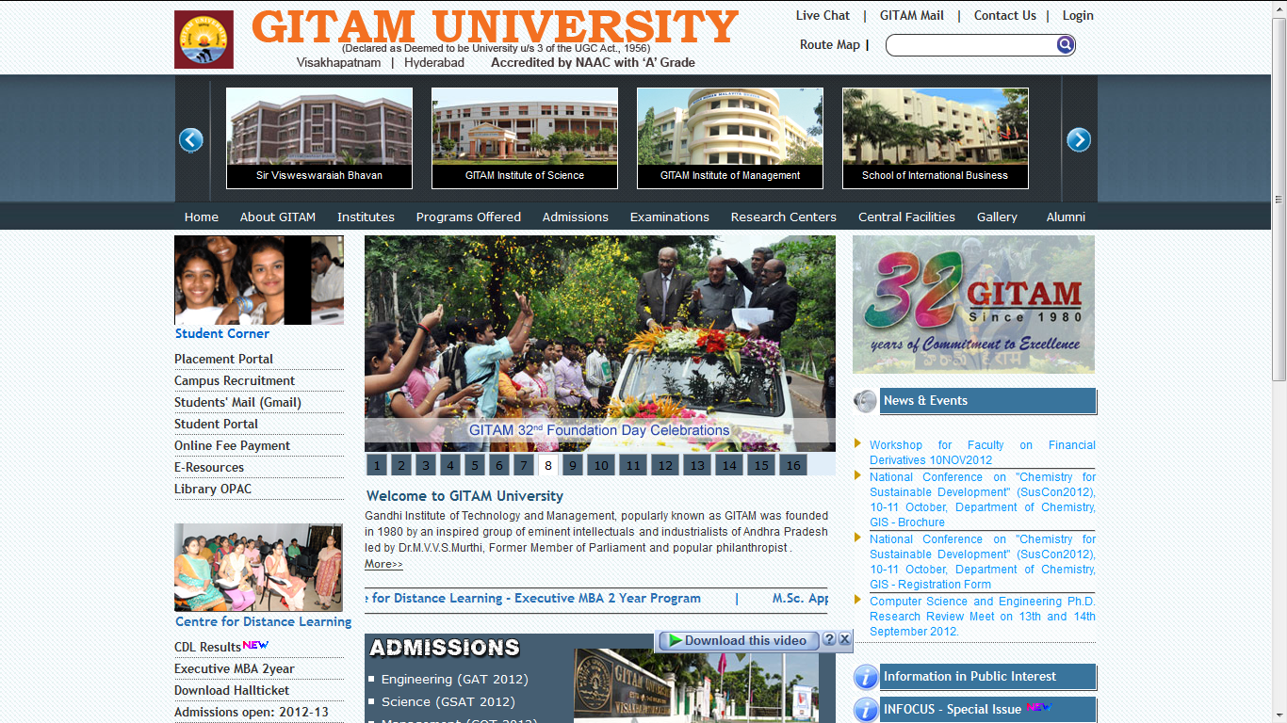

**Figure-22: Desktop layout**

When any device having a minimum screen size of 1024px width sends a request to the web server for the home page then the above shown layout is displayed on their device browsers.

**7.7 Tablet layout (portrait)**

The below shown is the screen shot of the Tablet version of the home page. For the tablet version the minimum screen size that is taken into consideration is 600px width. The tablets having the minimum screen resolution of 600 px width, will be applied with the css file located in css_600 folder.

The following is the media queries used to detect the tablet devices.

<link rel="stylesheet" type="text/css" media="only screen and (min-width:600px)" href="css_600/hmenu_style_600.css" />

<link rel="stylesheet" type="text/css" media="only screen and (min-width:600px)" href="css_600/stylesheet_600.css"/>

<link rel='stylesheet' type="text/css" media="only screen and (min-width:600px)" href="css_600/02_600.css"/>

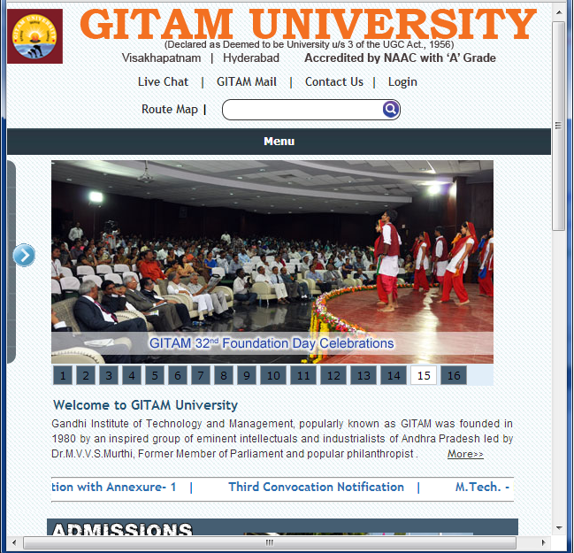

**Figure-23: Tablet layout (portrait)**

When any device having a minimum screen size of 600px width sends a request to the web server for the home page then the above shown layout is displayed on their device browsers.

**7.8 Tablet layout (landscape)**

The below shown is the screen shot of the Tablet version of the home page. For the tablet version the minimum screen size that is taken into consideration is 760px width. The tablets having the minimum screen resolution of 760 px width, will be applied with the css file located in css_760 folder.

The following is the media queries used to detect the tablet devices.

<link rel="stylesheet" type="text/css" media="only screen and (min-width:760px)" href="css_760/hmenu_style_760.css" />

<link rel="stylesheet" type="text/css" media="only screen and (min-width:760px)" href="css_760/stylesheet_760.css"/>

<link rel='stylesheet' type="text/css" media="only screen and (min-width:760px)" href="css_760/02_760.css"/>

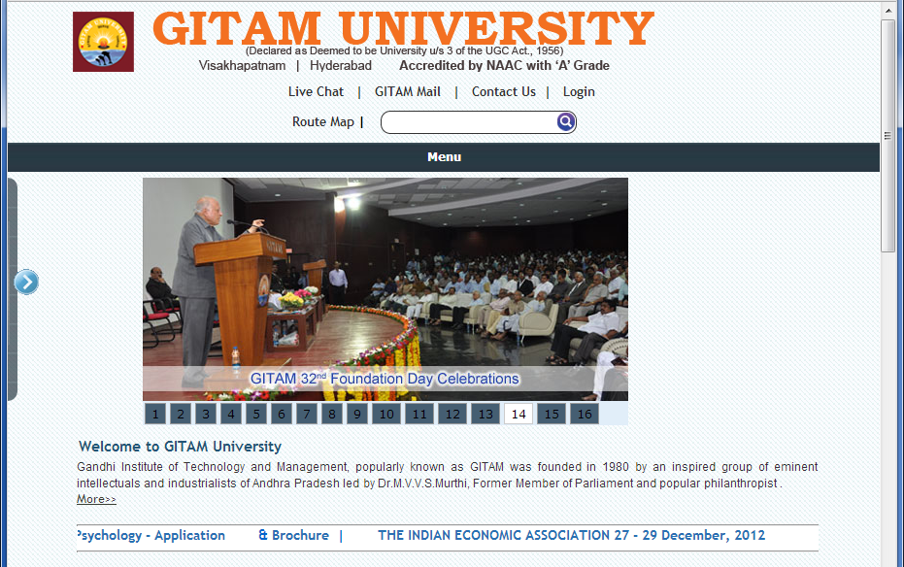

**Figure-24: Tablet layout (landscape)**

When any device having a minimum screen size of 760px width sends a request to the web server for the home page then the above shown layout is displayed on their device browsers.

**7.8.1 Mobile layout (portrait):**

The below shown is the screen shot of the Mobile version of the home page. For the Mobile version the minimum screen size that is taken into consideration is 320px width. The Mobiles having the minimum screen resolution of 320 px width, will be applied with the css file located in css_320 folder.

The following is the media queries used to detect the mobile devices.

<link rel="stylesheet" type="text/css" media="only screen and (min-width:320px)" href="css_320/hmenu_style_320.css" />

<link rel="stylesheet" type="text/css" media="only screen and (min-width:320px)" href="css_320/stylesheet_320.css"/>

<link rel='stylesheet' type="text/css" media="only screen and (min-width:320px)" href="css_320/02_320.css"/>

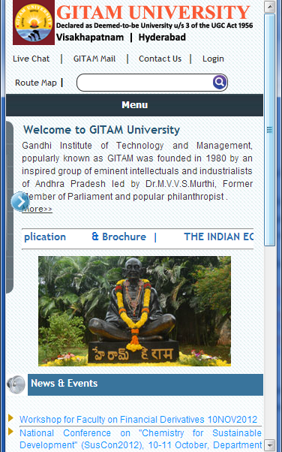

**Figure-25: Mobile layout (portrait)**

When any device having a minimum screen size of 320px width sends a request to the web server for the home page

**7.8.2 Mobile layout (landscape)**

The below shown is the screen shot of the Mobile version of the home page. For the Mobile version the minimum screen size that is taken into consideration is 480px width. The Mobiles having the minimum screen resolution of 480 px width, will be applied with the css file located in css_480 folder.

The following is the media queries used to detect the mobile devices.

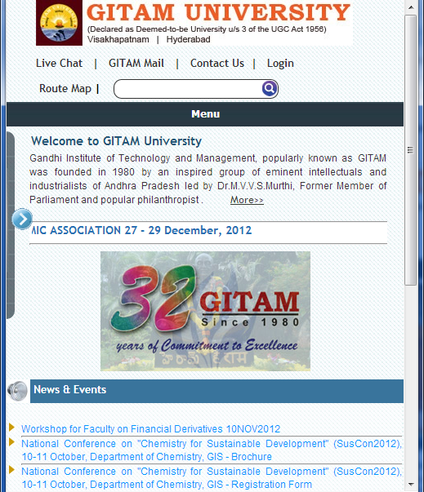

**Figure-26:Mobile layout (landscape)**

When any device having a minimum screen size of 480px width sends a request to the web server for the home page then the above shown layout is displayed on their device browsers.

**HomePage.Master**

<%@ Master Language="C#" AutoEventWireup="true" CodeBehind="HomePage.master.cs" Inherits="student_project.HomePage" %>

<%@ Register src="MainBanner.ascx" tagname="MainBanner" tagprefix="uc1" %>

<%@ Register src="MainHeader.ascx" tagname="MainHeader" tagprefix="uc3" %>

<%@ Register src="LeftMenu.ascx" tagname="LeftMenu" tagprefix="uc4" %>

<%@ Register src="Footer.ascx" tagname="Footer" tagprefix="uc5" %>

<%@ Register src="Horizontal_menu2.ascx" tagname="Horizontal_menu2" tagprefix="uc2" %>

<%@ Register src="CopyRights.ascx" tagname="CopyRights" tagprefix="uc6" %>

<!DOCTYPE html PUBLIC "-//W3C//DTD XHTML 1.0 Transitional//EN" "http://www.w3.org/TR/xhtml1/DTD/xhtml1-transitional.dtd">

<html xmlns="http://www.w3.org/1999/xhtml" >

<head runat="server">

<meta name="viewport" content="width=device-width" />

<link id="Link1" rel="shortcut icon" href="~/favicon.ico" type="image/x-icon"/>

<link id="Link2" rel="icon" href="~/favicon.ico" type="image/ico"/>

<title>Welcome to GITAM University</title>

<asp:ContentPlaceHolder ID="head" runat="server">

</asp:ContentPlaceHolder>

<!-- 320 css -->

<link rel="stylesheet" type="text/css" media="only screen and (min-width:320px)" href="css_320/hmenu_style_320.css" />

<link rel="stylesheet" type="text/css" media="only screen and (min-width:320px)" href="css_320/stylesheet_320.css"/>

<link rel='stylesheet' type="text/css" media="only screen and (min-width:320px)" href="css_320/02_320.css"/>

<!--

<link rel="stylesheet" type="text/css" media="only screen and (min-width:320px)" href="css_320/hmenu_ie6_style_320.css" />

<link rel="stylesheet" type="text/css" media="only screen and (min-width:320px)" href="css_320/style_middletabs_320.css" />

<link rel="stylesheet" type="text/css" media="only screen and (min-width:320px)" href="css_320/stylesheet2_320.css" />

-->

<!-- end of 320 css -->

<!-- 480 css -->

<link rel="stylesheet" type="text/css" media="only screen and (min-width:480px)" href="css_480/hmenu_style_480.css" />

<link rel="stylesheet" type="text/css" media="only screen and (min-width:480px)" href="css_480/stylesheet_480.css"/>

<link rel='stylesheet' type="text/css" media="only screen and (min-width:480px)" href="css_480/02_480.css"/>

<!--

<link rel="stylesheet" type="text/css" media="only screen and (min-width:480px)" href="css_480/hmenu_ie6_style_480.css" />

<link rel="stylesheet" type="text/css" media="only screen and (min-width:480px)" href="css_480/style_middletabs_480.css" />

<link rel="stylesheet" type="text/css" media="only screen and (min-width:480px)" href="css_480/stylesheet2_480.css" />

-->

<!--end of 480 css -->

<!-- 600 css -->

<link rel="stylesheet" type="text/css" media="only screen and (min-width:600px)" href="css_600/hmenu_style_600.css" />

<link rel="stylesheet" type="text/css" media="only screen and (min-width:600px)" href="css_600/stylesheet_600.css"/>

<link rel='stylesheet' type="text/css" media="only screen and (min-width:600px)" href="css_600/02_600.css"/>

<!--

<link rel="stylesheet" type="text/css" media="only screen and (min-width:600px)" href="css_600/hmenu_ie6_style_600.css" />

<link rel="stylesheet" type="text/css" media="only screen and (min-width:600px)" href="css_600/style_middletabs_600.css" />

<link rel="stylesheet" type="text/css" media="only screen and (min-width:600px)" href="css_600/stylesheet2_600.css" />

-->

<!-- end of 600 css -->

<!-- 760 css -->

<link rel="stylesheet" type="text/css" media="only screen and (min-width:760px)" href="css_760/hmenu_style_760.css" />

<link rel="stylesheet" type="text/css" media="only screen and (min-width:760px)" href="css_760/stylesheet_760.css"/>

<link rel='stylesheet' type="text/css" media="only screen and (min-width:760px)" href="css_760/02_760.css"/>

<!--

<link rel="stylesheet" type="text/css" media="only screen and (min-width:760px)" href="css_760/hmenu_ie6_style_760.css" />

<link rel="stylesheet" type="text/css" media="only screen and (min-width:760px)" href="css_760/style_middletabs_760.css" />

<link rel="stylesheet" type="text/css" media="only screen and (min-width:760px)" href="css_760/stylesheet2_760.css" />

-->

<!-- end of 760 css -->

<!--1024 css-->

<link rel="stylesheet" type="text/css" media="only screen and (min-width:1024px)" href="css/hmenu_style.css" />

<link rel="stylesheet" type="text/css" media="only screen and (min-width:1024px)" href="css/stylesheet.css"/>

<link rel='stylesheet' type="text/css" media="only screen and (min-width:1024px)" href="css/02.css"/>

<!--<link rel="stylesheet" type="text/css" media="only screen and (min-width:760px)" href="css/hmenu_ie6_style.css" />-->

<!--<link rel="stylesheet" type="text/css" media="only screen and (min-width:760px)" href="css/style_middletabs.css" />-->

<!--<link rel="stylesheet" type="text/css" media="only screen and (min-width:760px)" href="css/stylesheet2.css" />-->

<!-- end of 1024 css-->

<script type="text/javascript" src="js/jquery-latest.js"></script>

<script type="text/javascript" src="js/menu.js"></script>

<script type="text/javascript" src="js/jcarousellite_1.0.1.min.js"></script>

<script type="text/javascript" src="js/jquery.easing.min.js"></script>

<script type="text/javascript" src="js/jquery.colorbox-min.js"></script>

<script type="text/javascript" src="js/jquery.lavalamp.min.js"></script>

<script type="text/javascript">

$(function() {

$("#project-slider").jCarouselLite({

btnNext: ".next",

btnPrev: ".prev",

// easing: "bounceout",

auto: 4500,

speed: 800,

autoStart: 1000,

visible: 4

});

});

$(document).ready(function(){

$("a[rel='mini']").colorbox({transition:"elastic", maxWidth:'90%', maxHeigt:'90%'});

$("a[rel='peep']").colorbox({transition:"elastic", width:"610px", height:"410px"});

$("a[rel='peeplink']").colorbox({transition:"elastic", width:"610px", height:"410px"});

$("a[rel='eventpics']").colorbox({transition:"elastic"});

$(".video").colorbox({ transition:"elastic",iframe:true, width:"595px", height:"410px"});

});

</script>

<!--<script src="js/loopedslider.js" type="text/javascript" charset="utf-8"></script> -->

<!--google search start -->

<script src="//www.google.com/jsapi" type="text/javascript"></script>

<script type="text/javascript">

google.load('search', '1', {language : 'en'});

google.setOnLoadCallback(function() {

var customSearchControl = new google.search.CustomSearchControl(

'016012185390064641722:vsugipd8xte');

customSearchControl.setResultSetSize(google.search.Search.FILTERED_CSE_RESULTSET);

customSearchControl.draw('cse');

}, true);

</script>

<!-- google search end -->

<script type="text/javascript">

$(document).ready(function () {

$("#menu_320_link").click(function () {

$("#menubar_320").slideToggle('slow');

});

$("#about_gitam").mouseover(function () {

$("#about_gitam_child_ul").show();

});

$("#about_gitam").mouseleave(function () {

$("#about_gitam_child_ul").hide();

});

$("#about_gitam_child_ul").mouseleave(function () {

$("#about_gitam_child_ul").hide();

});

$("#Institutes").mouseover(function () {

$("#Institutes_child_ul").show();

});

$("#Institutes").mouseleave(function () {

$("#Institutes_child_ul").hide();

});

$("#Institutes_child_ul").mouseleave(function () {

$("#Institutes_child_ul").hide();

});

$("#pro_offered").mouseover(function () {

$("#pro_offered_child_ul").show();

});

$("#pro_offered").mouseleave(function () {

$("#pro_offered_child_ul").hide();

});

$("#pro_offered_child_ul").mouseleave(function () {

$("#pro_offered_child_ul").hide();

});

$("#admissions").mouseover(function () {

$("#admissions_child_ul").show();

});

$("#admissions").mouseleave(function () {

$("#admissions_child_ul").hide();

});

$("#admissions_child_ul").mouseleave(function () {

$("#admissions_child_ul").hide();

});

$("#examinations").mouseover(function () {

$("#examinations_child_ul").show();

});

$("#examinations").mouseleave(function () {

$("#examinations_child_ul").hide();

});

$("#examinations_child_ul").mouseleave(function () {

$("#examinations_child_ul").hide();

});

$("#research_centers").mouseover(function () {

$("#research_centers_child_ul").show();

});

$("#research_centers").mouseleave(function () {

$("#research_centers_child_ul").hide();

});

$("#research_centers_child_ul").mouseleave(function () {

$("#research_centers_child_ul").hide();

});

$("#central_facilities").mouseover(function () {

$("#central_facilities_child_ul").show();

});

$("#central_facilities").mouseleave(function () {

$("#central_facilities_child_ul").hide();

});

$("#central_facilities_child_ul").mouseleave(function () {

$("#central_facilities_child_ul").hide();

});

$("#left_content_320_right_arrow").click(function () {

$("#left_content_320").hide();

$("#leftcontent").show(1000);

});

$(".leftmenu_320_img").click(function () {

$("#leftcontent").hide(1000);

$("#left_content_320").show(1000);

});

});

</script>

</head>

<body>

<form id="form1" runat="server">

<!--top start-->

<uc3:MainHeader ID="MainHeader1" runat="server"/>

<div id="flash_bannerbg">

<div id="flash_banner">

<div id="project-front">

<div class="prev"><img src="images/left-arrow.gif" border="0" alt="" /></div>

<div class="next"><img src="images/right-arrow.gif" border="0" alt="" /></div>

<div id="project-slider">

<ul>

<li class="slide" style="background: transparent url(images/1.jpg) no-repeat; width:196px; height:106px;">

<div class="positionSlide"><a href="#"> <span>GITAM Main Gate</span></a></div>

</li>

<li class="slide" style="background:url(images/2.jpg) no-repeat; width:196px; height:106px;">

<div class="positionSlide"><a href="http://www.gitam.edu/aboutus.aspx"> <span>Gandhiji (inside GITAM)</span></a></div>

</li>

<li class="slide" style="background:url(images/03.jpg) no-repeat; width:196px; height:106px;">

<div class="positionSlide"><a href="http://www.gitam.edu/aboutus.aspx"> <span>GITAM Bhavan</span></a></div>

</li>

<li class="slide" style="background:url(images/8.jpg) no-repeat; width:196px; height:106px;">

<div class="positionSlide"><a href="http://www.gitam.edu/GIT/aboutus.aspx"> <span>Chandrahas Bhavan(ICT Building)</span></a></div>

</li>

<li class="slide" style="background:url(images/3.jpg) no-repeat; width:196px; height:106px;">

<div class="positionSlide"><a href="http://www.gitam.edu/GIT/aboutus.aspx"> <span>GITAM Institute of Technology</span></a></div>

</li>

<li class="slide" style="background:url(images/visweswaraiahbhavan.jpg) no-repeat; width:196px; height:106px;">

<div class="positionSlide"><a href="http://www.gitam.edu/GIT/aboutus.aspx"> <span>Sir Visweswaraiah Bhavan</span></a></div>

</li>

<li class="slide" style="background:url(images/4.jpg) no-repeat; width:196px; height:106px;">

<div class="positionSlide"><a href="http://www.gitam.edu/GIS/aboutus.aspx"> <span>GITAM Institute of Science</span></a></div>

</li>

<li class="slide" style="background:url(images/5.jpg) no-repeat; width:196px; height:106px;">

<div class="positionSlide"><a href="http://www.gitam.edu/GIM/GIMaboutus.aspx"> <span>GITAM Institute of Management</span></a></div>

</li>

<li class="slide" style="background:url(images/gsib.jpg) no-repeat; width:196px; height:106px;">

<div class="positionSlide"><a href="http://www.gsib.org" target="_blank" > <span>School of International Business</span></a></div>

</li>

<li class="slide" style="background:url(images/7.jpg) no-repeat; width:196px; height:106px;">

<div class="positionSlide"><a href="http://www.gitam.edu/GIP/aboutus.aspx"> <span>GITAM Institute of Pharmacy</span></a></div>

</li>

<li class="slide" style="background:url(images/GSA.jpg) no-repeat; width:196px; height:106px;">

<div class="positionSlide"><a href="http://www.gitam.edu/GSA/AboutGSA.aspx"> <span>GITAM School of Architecture</span></a></div>

</li>

<li class="slide" style="background:url(images/law.jpg) no-repeat; width:196px; height:106px;">

<div class="positionSlide"><a href="http://www.gitam.edu/SOL/welcomePage.aspx"> <span>School of LAW</span></a></div>

</li>

<li class="slide" style="background:url(images/krc_building.jpg) no-repeat; width:196px; height:106px;">

<div class="positionSlide"><a href="http://www.gitam.edu/Library/AboutUs.aspx?id=573"> <span>KRC (Central Library)</span></a></div>

</li>

<li class="slide" style="background:url(images/9.jpg) no-repeat; width:196px; height:106px;">

<div class="positionSlide"><a href="http://www.gitam.edu/Hyderabad/aboutus.aspx"> <span>Hyderabad Campus</span></a></div>

</li>

</ul>

</div>

</div>

</div>

</div>

<!--banner end-->

<!--Horizontal Manu start-->

<div id="horizontal-navbg">

<a style="text-decoration:none;color:White" href="#" id="menu_320_link"><div id="menu_320">Menu</div></a>

<div id="horizontal-nav">

<uc2:Horizontal_menu2 ID="Horizontal_menu21" runat="server" />

</div>

</div>

<!-- <div class="mainbg_1"> -->

<asp:ContentPlaceHolder ID="ContentPlaceHolder1" runat="server">

<!--Horizontal Manu end-->

<div id="maincontent">

<div id="leftcontent1">

</div>

</div>

</asp:ContentPlaceHolder>

<!--</div> -->

<div class="clear" style="height:0px;"></div>

<div style="height:30px"></div>

<%--<div style="height:30px;"></div>--%>

<!--footer start-->

<uc5:Footer ID="Footer1" runat="server" />

<!--footer end-->

<uc6:CopyRights ID="CopyRights1" runat="server" />

<%-- <--copyrights start---> --%><div>

</div>

<%-- <--copyrights end---> --%>

</form>

</body>

</html>

**WelcomePage.aspx**

<%@ Page Language="C#" MasterPageFile="~/HomePage.Master" AutoEventWireup="true" CodeBehind="WelcomePage.aspx.cs" Inherits="student_project.WelcomePage" Title="Welcome to GITAM University" %>

<%--<%@ Register src="NewsEvents.ascx" tagname="NewsEvents" tagprefix="uc2" %>--%>

<asp:Content ID="Content1" ContentPlaceHolderID="head" runat="server">

</asp:Content>

<asp:Content ID="Content2" ContentPlaceHolderID="ContentPlaceHolder1" runat="server">

<div id="maincontent" >

<%-- leftcontent start--%>

<div id="left_content_320"><a href="#"><img src="Images/right-arrow.gif" alt="right arrow" id="left_content_320_right_arrow" /></a></div>

<div id="leftcontent">

<div id="marquee_iframe"><iframe scrolling="no" src="marquee_studentcorner/index.html" border="0" allowtransparency="true" frameborder="0" height="95px;" width="180" name="stc"></iframe></div>

<!--

<div style="background-image:url(Images/studentcorner_image1.jpg); height:95px; width:180px"></div> -->

<div class="subhead1" align="left">Student Corner </div>

<div id="homeleftmenu" >

<ul>

<li> <a href="gitamPlacement.aspx" >Placement Portal </a></li>

<li><a href="http://gitam.elitmus.com/student_login" target="_blank">Campus Recruitment</a></li>

<li><a href="http://mail.gitam.in" target="_blank">Students' Mail (Gmail)</a></li>

<li><a href="http://webadmissions.gitam.edu:81/studentportal/pages/login.aspx" target="_blank">Student Portal </a></li>

<li><a href="http://epay.gitam.edu/paymentportal/Makepayment.aspx" target="_blank" >Online Fee Payment</a></li>

<li><a href="eresource/endex.htm"target="_blank">E-Resources </a> </li>

<li><a href="http://192.168.25.10:8100/web" target="_blank">Library OPAC </a></li>

<!--<li><a href="http://www.gitam.edu/Lifeatgitam.htm" target="_blank">Life at GITAM (Video)</a><img src="Images/new.gif" /></li>-->

</ul>

</div>

<div id="blank_space"><a href="#"><img src="Images/left-arrow-leftmenu.gif" class="leftmenu_320_img" alt="left arrow"/></a></div>

<div id="homecdimg" style="background-image:url(Images/homecdlimage1.jpg); height:95px; width:180px "></div>

<div class="subhead1" align="left" style="height:25px;" ><a href="http://www.gitam.edu/CDL/WelcomePage.aspx"> Centre for Distance Learning</a> </div>

<div id="homeleftmenu">

<ul>

<li><a href="http://doeresults.gitam.edu/onlineresults/pages/grdcrdinput.aspx">CDL Results</a><img src="Images/new.gif" alt="gitam cdl" /></li>

<li><a href="http://www.gitam.edu/CDL/WelcomePage.aspx" >Executive MBA 2year </a></li>

<!--<li><a href="http://webadmissions.gitam.edu:81/cdlhallticket/cdlhallticket.aspx" target="_blank">CDL Hallticket Download</a><img src="Images/new.gif" /></li>-->

<li><a href="http://webadmissions.gitam.edu:81/cdlhallticket/cdlhallticket.aspx">Download Hallticket</a></li>

<!--<li><a href="CDL/Academic_Syllabus.aspx">Programs Offered</a></li>-->

<li><a href="CDL/images/cdl_ntfc2012.pdf" target="_blank">Admissions open: 2012-13</a></li>

<li><a href="CDL/bcom.aspx">B.A/B.Com Open Admissions</a></li>

<!--<li><a href="CDL/Studycentres.aspx" target="_blank">Study Centres</a></li>-->

<li><a href="CDL/WelcomePage.aspx">Learning Zone</a></li>

<li><a href="http://xlearn.gitam.edu/moodle/login/index.php" target="_blank">Online Learning (X-learn)</a> </li>

<li><a href="http://webadmissions.gitam.edu:81/cdlstudycentre/LoginPage.aspx" target="_blank">CDL Study Centre Portal</a> </li>

<%--<li><a href="#">Contact Us</a> </li>--%>

</ul>

</div>

<div id="blank_space"><a href="#"><img src="Images/left-arrow-leftmenu.gif" class="leftmenu_320_img" alt="left arrow"/></a></div>

<div id="krc_img" style="background-image:url(Images/krc_homeimg.jpg); height:95px; width:180px "></div>

<div class="subhead1" align="left" id="learning_center">Learning Center </div>

<div id="homeleftmenu">

<ul>

<li><a href="http://www.gitam.edu/Library/AboutUs.aspx?id=573">Library</a></li>

<!-- <li><a href="http://webadmissions.gitam.edu:81/cdlhallticket/hall_number.aspx">Download Hallticket</a></li> -->

<li><a href="http://www.gitam.edu/CentralFacilities/Content.aspx?id=204">E-Learning Research Centre</a></li>

<li><a href="http://www.gitam.edu/Library/Paper.aspx">Question Papers</a></li>

<li><a href="http://www.gitam.edu/Library/library.aspx?id=1063">Downloads</a></li>

</ul>

</div>

<div id="blank_space"><a href="#"><img src="Images/left-arrow-leftmenu.gif" class="leftmenu_320_img" alt="left arrow"/></a></div>

<div class="subhead1" align="left" id="portals">portals</div>

<div id="homeleftmenu" >

<ul id="portals">

<li><a href="http://web.gitam.edu/ssportal/pages/Default.aspx" target="_blank">Staff Portal</a></li>

<li><a href="http://web.gitam.edu/attendance/pages/Default.aspx" target="_blank">Attendance Portal</a></li>

<li><a href="http://web.gitam.edu/asset_request/pages/LoginPage.aspx" target="_blank">Assets Portal</a></li>

<li><a href="http://webadmissions.gitam.edu:81/onlineadmission/Default.aspx" target="_blank">GIM Admissions Portal</a></li>

<li><a href="http://webadmissions.gitam.edu:81/gimplacementportal/Pages/login_placementportal.aspx" target="_blank">Placement Portal</a></li>

<li><a href="http://192.168.23.50/cdlportal/LoginPage.aspx" target="_blank">CDL Portal</a></li>

<li><a href="http://webadmissions.gitam.edu:81/studentportal/pages/login.aspx" target="_blank">Student Portal</a></li>

<li><a href="http://doeresults.gitam.edu/onlineresults/pages/grdcrdinput.aspx" target="_blank" >GITAM Exam Results</a></li>

<li><a href="http://epay.gitam.edu/paymentportal/UBIOtherPayments1.aspx" target="_blank" > Miscellaneous Challan</a></li>

<li><a href="http://ims.gitam.edu" target="_blank" >IMS Portal</a></li>

</ul>

</div>

</div>

<%--leftcontent end--%>

<div id="middlecontent">

<div >

<div id="tinyfader_slider">

<!--

<object classid="clsid:D27CDB6E-AE6D-11cf-96B8-444553540000" codebase="http://download.macromedia.com/pub/shockwave/cabs/flash/swflash.cab#version=7,0,19,0" width="500" height="230">

<param name="movie" value="images/banner.swf" />

<param name="quality" value="high" />

<param name="wmode" value="transparent"/>

<embed src="images/banner.swf" quality="high" pluginspage="http://www.macromedia.com/go/getflashplayer" type="application/x-shockwave-flash" width="500" height="230" wmode="transparent"></embed>

</object>

-->

<iframe frameborder="0" width="500px" height="255px" scrolling="no" src= "tinyfader/index.html"> </iframe>

</div>

<div class="welcomemessage">

<div class="font" style="text-align:justify;">

<div class="subhead3" style="height:20px">Welcome to GITAM University</div>

<div style="font-family:arial; font-size:12px; ">

Gandhi Institute of Technology and Management, popularly known as GITAM was founded in 1980 by an inspired group of eminent intellectuals and industrialists of Andhra Pradesh led by Dr.M.V.V.S.Murthi, Former Member of Parliament and popular philanthropist

.&nbsp;&nbsp;&nbsp;&nbsp;&nbsp;&nbsp;&nbsp;&nbsp;&nbsp;&nbsp; <span class="more" ><a href="aboutus.aspx"> More>> </a></span>

</div>

<br />

<hr />

<!--<marquee direction="left" onmouseover="stop()"; onmouseout="start()"; scrollamout="1" width="100%;" height="25px;" style="font-family:verdana; font-size:12px; font-weight:bold;" >

Invitation for GITAM alumni meet at Dallas, Texas on 22<sup>nd</sup> october 2011:<a href="Images/GitamAlumniEvent_N_.pdf" target="_blank">Download pdf </a> / <a href="http://www.punchbowl.com/parties/2697777-gitam-alumni-meet?5195954" target="_blank"> Please Join us</a></marquee>-->

<p class="subhead1" >

<marquee direction="left" onmouseover="stop()"; onmouseout="start()"; scrollamout="1" width="100%;" height="22px;" >

<!--

<span style="margin-right:30px; margin-left:30px;" ><a href="http://www.eliveevents.com/gitam" target="_blank" > <span class="subhead5" > Live Telecast - 32nd Foundation Day Celebrations (starts today from 3pm onwards) </span> </a> <img src="Images/new.gif" alt="gitam" /></span> and

<span style="margin-right:30px; margin-left:30px;" > <span class="subhead5" > Live Telecast On hmtv </span> <img src="Images/new.gif" alt="gitam" /></span> |

<span style="margin-right:30px; margin-left:30px;" ><a href="http://www.gitam.edu/invitation_gitam.html" target="_blank" > Invitation for 32nd Foundation Day Celebrations </a> <img src="Images/new.gif" alt="gitam" /></span>

<span style="margin-right:30px;"><a href="http://webadmissions.gitam.edu:81/recruitment/notification.aspx" target="_blank"> Faculty Recruitment </a></span>|--%>

-->

<span style="margin-right:30px; margin-left:30px;"><span><a href="Images/Application_and_Annexure.pdf" target="_blank" >Convocation Application with Annexure- 1</a></span> &nbsp; |&nbsp;

<span style="margin-right:30px; margin-left:30px;"><span><a href="Images/convocation_Notification.pdf" target="_blank" >Third Convocation Notification</a></span> &nbsp; |&nbsp;

<%--<span style="margin-right:30px;"><a href="http://webadmissions.gitam.edu:81/faculty/notification.aspx" target="_blank"> Faculty Recruitment For Engg.Chemistry </a></span>&nbsp; |&nbsp;--%>

<span style="margin-left:30px;"><a href= "http://www.gitam.edu/Admissions/evng_programs.htm" target= "_blank">M.Tech. - Evening Programs(2012-13)</a> </span> &nbsp; |&nbsp;

<span style="margin-right:30px; margin-left:30px;"><a href="http://www.gitam.edu/CDL/WelcomePage.aspx"> Centre for Distance Learning - Executive MBA 2 Year Program </a></span>|

<span style="margin-right:30px; margin-left:30px;"><a href="Images/Psychology_brochure_2012.pdf" target="_blank"> M.Sc. Applied Psychology - Application</a></span> & <span><a href="Images/PSY_brochure.pdf" target="_blank" >Brochure</a></span>&nbsp; |

<span style="margin-right:30px; margin-left:30px;"><span><a href="Images/IEA_BROCHURE.pdf" target="_blank" >THE INDIAN ECONOMIC ASSOCIATION 27 - 29 December, 2012</a></span>

<!--

<span style="margin-left:30px;"><a href= "http://webadmissions.gitam.edu/ccl" target= "_blank">GAT 2012 - Final Phase Counseling Call Letter </a> </span>

<span style="margin-left:30px;"><a href= "http://gat2012.gitam.edu" target= "_blank">Counseling Vacancy Position </a><img src="Images/new.gif" /> </span>

-->

</marquee>

<hr />

</div>

</div>

<div > <!--admissions tab box start -->

<div class="adms-box">

<table width="490" border="0" cellspacing="0" cellpadding="0" class="admi-tabbox">

<tr>

<td height="40" valign="top" class="adms-title">&nbsp;</td>

<td width="287" rowspan="2" align="center" valign="middle"><img src="Images/adms_img2.jpg" alt="gitam" /> </td>

</tr>

<tr>

<td width="213">

<div class="admi-box">

<ul>

<li><a href="http://www.gitam.edu/Admissions/aboutus.aspx">Engineering (GAT 2012)</a></li>

<li><a href="http://www.gitam.edu/GIS/GISAdmissions.aspx">Science (GSAT 2012)</a></li>

<li><a href="http://webadmissions.gitam.edu:81/onlineadmission/Default.aspx">Management (GOT 2012) </a> </li>

</ul>

</div>

</td>

</tr>

<tr>

<td colspan="2"><ul>

<li><a href="http://www.gsib.org/" >School of International Business(GIFT):MBA 2012-2014 </a></li>

<li>Pharmacy Spot Admissions : <a href= "Images/B_Pharmacy.pdf" target= "_blank">B.Pharmacy </a> & <a href= "Images/M_Pharmacy.pdf" target= "_blank">M.Pharmacy </a></li>

<li><a href="http://www.gitam.edu/GSA/Content.aspx?id=934">Architecture (B.Arch – 2012) </a><!--<img src="Images/new.gif" />--></li>

<li><a href="http://www.gitam.edu/SOL/welcomePage.aspx">School of LAW (GLAT - 2012) </a><img src="Images/new.gif" alt="gitam law college" /></li>

<li><a href="http://www.ghbs.in/">MBA Admissions@Hyderabad (HBSAT 2012-2014) </a></li>

<li><a href="http://www.gitam.edu/CDL/WelcomePage.aspx" >Centre for Distance Learning Admissions </a></li>

</ul></td>

</tr>

</table>

</div> <!--tabbox end-->

</div> <!--admissins tab box end -->

<div style="margin-top:8px"><img src="Images/home_greencampus.jpg" alt="gitam campus" id="green_campus_img" /></div>

</div>

</div>

<div id="rightcontent">

<div>

<div id="gitam_object"><object classid="clsid:D27CDB6E-AE6D-11cf-96B8-444553540000" codebase="http://download.macromedia.com/pub/shockwave/cabs/flash/swflash.cab#version=7,0,19,0" width="257" height="147">

<param name="movie" value="images/gandhiji.swf" />

<param name="quality" value="high" />

<param name="wmode" value="transparent">

<embed src="images/gandhiji.swf" quality="high" pluginspage="http://www.macromedia.com/go/getflashplayer" type="application/x-shockwave-flash" width="257" height="147" wmode="transparent"></embed>

</object>

</div>

<%-- <div><img src="Images/gandhiji_topnews.jpg" /> </div>--%>

<div style="height:10px"></div>

<div class="bg_strip" align="left" id="newsnevents" >

<span style="float:left"><img src="images/news_image.jpeg" width="29" height="29" border="0" alt="gitam" /></span>&nbsp;News

&amp; Events</div>

<table><tr><td >

<div class="newsdiv" runat="server" >

<%--<uc2:newsevents ID="NewsEvents1" runat="server" />--%>

<br />

<div class="news" style="padding-left:16px;" >

<ul>

<li><a href="#"> Workshop for Faculty on Financial Derivatives 10NOV2012 </a></li> <hr />

<li><a href="#"> National Conference on "Chemistry for Sustainable Development" (SusCon2012), 10-11 October, Department of Chemistry, GIS - Brochure

</a> </li><hr />

<li><a href="#"> National Conference on "Chemistry for Sustainable Development" (SusCon2012), 10-11 October, Department of Chemistry, GIS - Registration Form

</a> </li><hr />

<li><a href="#"> Computer Science and Engineering Ph.D. Research Review Meet on 13th and 14th September 2012. </a> </li>

</ul>

</div>

</div>

</td></tr></table>

</div>

<div>

<!-- <div class="subhead4" >Life at GITAM </div> -->

<object type="video/x-ms-wmv" data="Images/gitamvideo.wmv" width="260" height="175">

<param name="url" value="Images/amazing.wmv"/>

<param name="src" value="Images/amazing.wmv" />

<param name="autostart" value="false" />

<param name="sound" value="false" />

<param name="controller" value="true" />

</object>

<!--

<div class="subhead4" id="life_gitam">Life at GITAM </div>

<iframe id="life_gitam_video" src="http://player.vimeo.com/video/31994100?title=0&amp;byline=0&amp;portrait=0" width="260" height="146" frameborder="0" webkitAllowFullScreen mozallowfullscreen allowFullScreen></iframe>--> </div>

<div style="height:10px"></div>

<div>

<div>

<div class="bg_strip" align="left" style="margin-bottom:6px"><span style="float:left"><img src="images/information_image.jpg" width="29" height="29" alt="gitam"/ ></span>&nbsp;<asp:LinkButton PostBackUrl="~/IPI/HomePage.aspx" runat="server">Information in Public Interest</asp:LinkButton></div>

<div class="bg_strip" align="left" style="margin-bottom:6px"><span style="float:left"><img src="images/information_image.jpg" width="29" height="29" alt="gitam"/ ></span>&nbsp;<a href="Images/INFOCUS_2012.pdf" target="_blank" >INFOCUS - Special Issue</a> <img src="Images/new.gif" /> </div>

</div>

<div class="bg_strip" align="left" style="margin-bottom:6px" ><span style="float:left"><img src="images/pastevents_image.jpg" width="29" height="29" border="0" alt="gitam"/></span>&nbsp;<a href="Past-Events/album/index.html" >Past Events </a></div>

</div>

<div id="counter" runat="server" style="background-color:#235576; color:White; line-height:20px; font-family:Verdana; font-size:12px; ">Hit Count:<asp:Label ID="Label1" runat="server" Font-Bold="True"

Font-Italic="True" ></asp:Label>

</div>

</div>

</div>

</asp:Content>

**CSS files**

**Stylesheet_320**

/* CSS Document */

body

{

width:100%; margin:0; padding:0;

/* background-image:url(Images/header_bg.jpg);

height:80px;

background-repeat:repeat-x; */

background-image:url(../Images/body-bgnew.jpg);

background-repeat:repeat;

background-position: top center;

background-color:#e1eef9;

line-height:20px;

font-family:Verdana;

font-size:12px;

color:#333;

text-align:justify;

}

a:link

{

text-decoration:none;

color:#2870B3;

outline:0;

}

a:visited

{

text-decoration:none;

color:#2870B3;

outline:0;

}

a:hover

{

text-decoration:underline;

color:#2870B3;

outline:0;

}

.mainbg_1

{

background-image:url(../Images/mainbg_1.png);

background-repeat:repeat-x;

height:600px;

background-position:center top;

}

#header

{

height:255px; border:0px;

width:980px;

margin:0;

}

#flash_bannerbg

{

display:none;

background-image:url(../Images/banner_bg.jpg);

background-repeat:repeat-x;

height:135px;

width:100%;

}

#flash_banner

{

display:none;

width:980px;

height:136px;

margin:0 auto 0 auto;

border:0;

}

#flash_banner1

{

width:980px;

height:149px;

background-image:url(../Images/flash_banner.gif);

background-repeat:no-repeat;

background-position: left ;

}

#footer

{

font-family:Verdana, Geneva, sans-serif;

font-size:12px;

color:#060;

clear: both;

float: left;

height: 30px;

width: 980px;

text-align: right;

background-position: center center;

margin-left:auto;

margin-right:auto;

}

.bg_line {

background-image: url(../Images/bg_line.jpg);

background-repeat: repeat-x;

height:6px;

background-position: top;

}

#information

{

width:190px;

height:auto;

float:left;

padding-top: 10px;

padding-right: 10px;

padding-left: 10px;

background-color:#e9e9e9;

}

.logo_title

{

background-image:url(../images_new/logo_title_new.png);

background-repeat:no-repeat;

height:62px;

width:100%;

float:left;

margin:0 0;

}

#search

{

float:left;

margin:0;

width:100%;

height: 20px;

padding-top:5px;

}

#inputbox

{

width:220px;

float:right;

margin-top:10px;

height: 49px;

margin-left: 50px;

}

#submitdiv

{

width:60px;

float:right;

margin-top:10px;

}

.top

{

height:125px;

width:95%;

margin:0px auto 0px auto;

}

#horizontal-navbg

{

width:100%;

background-image:url(../Images/bg_hmenu.jpg);

height:30px;

background-repeat:repeat-x;

}

#menu_320

{

display:block;

color:White;

font-weight:bold;

text-align:center;

width:100%;

padding-top:4px;

}

#horizontal-nav

{

width:100%;

font-family:Tahoma, Geneva, sans-serif;

font-size:12px;

margin:0 auto 0 auto;

}

#maincontent

{

width:100%;

margin:6px auto 0 auto;

padding:0;

}

#left_content_320

{

height:230px;

width:10px;

background-image:url(../Images/bg_hmenu.jpg);

border-radius:0px 20px 20px 0px;

position:absolute;

opacity:0.7;

z-index:1000;

}

#left_content_320_right_arrow

{

text-decoration:none;

padding-top:40px;

border:none;

}

#leftcontent

{

display:none;

width:190px;

float:left;

margin:0 8px 0 0;

padding:0;

position:absolute;

z-index:1000;

}

#marquee_iframe

{

display:none;

}

#homecdimg

{

display:none;

}

#krc_img

{

display:none;

}

#homeleftmenu

{

width:190px;

padding:0;

}

#homeleftmenu ul

{

width:100%;

margin:0;

padding:0;

list-style-type:none;

vertical-align:middle;

text-align:left;

}

#homeleftmenu ul li

{

font-family:Verdana, Geneva, sans-serif;

font-size:12px;

border-bottom:#666 dotted 1px;

font-weight:bold;

background-image:url("../Images/bg_hmenu.jpg");

height:25px;

}

#homeleftmenu ul li a

{

font-family:Verdana, Geneva, sans-serif;

font-size:12px;

padding:0 0 15px 0;

color:white;

text-decoration:none;

border:0;

}

#homeleftmenu ul li a:hover

{

font-family:Verdana, Geneva, sans-serif;

font-size:12px;

color:#000;

border:0;

}

.bg_strip

{

background-color:#39749c;

width:100%;

height:29px; background-repeat:no-repeat;

font-family:"Trebuchet MS", Arial, Helvetica, sans-serif;

background-position:left;

font-size:13px;

font-weight:bold;

color:#FFF;

text-align:left;

line-height:25px;

}

.bg_strip a

{

font-family:"Trebuchet MS", Arial, Helvetica, sans-serif;

background-position:left;

font-size:13px;

font-weight:bold;

color:#FFF;

text-align:left;

line-height:25px;

}

.bg_strip a:hover

{

font-family:"Trebuchet MS", Arial, Helvetica, sans-serif;

background-position:left;

font-size:13px;

font-weight:bold;

color:Black;

text-align:left;

line-height:25px;

}

#blank_space

{

height:30px;

background-color: #39749C;

}

.leftmenu_320_img

{

float:right;

height:30px;

}

.subhead1

{

font-family:'Trebuchet MS', Arial, Helvetica, sans-serif;

font-size:14px;

height:25px;

color:#06C;

font-weight:bold;

text-align:left;

line-height:18px;

padding-left:3px;

background-color:white;

}

.subhead2

{

font-family:'Trebuchet MS', Arial, Helvetica, sans-serif;

font-size:18px;

color:Olive; font-weight: normal; line-height:18px;

width: 293px;

}

.subhead3

{

font-family:'Trebuchet MS', Arial, Helvetica, sans-serif;

font-size:15px;

color:#235576; font-weight: bold; line-height:18px;

padding:2px 0px 2px 2px;

}

.subhead4

{

font-family:'Trebuchet MS', Arial, Helvetica, sans-serif;

font-size:17px;

color:#235576; font-weight: normal; line-height:18px;

}

.subhead5

{

font-family:'Trebuchet MS', Arial, Helvetica, sans-serif;

font-size:20px;

color:Red; font-weight: bold;

}

.subhead6

{

font-family:'Trebuchet MS', Arial, Helvetica, sans-serif; font-size:13px; height:25px; color:#06C; font-weight:bold; text-align:left; line-height:18px; padding-left:1px;

}

pre

{ font-family :Verdana, Geneva, sans-serif;

font-size:12px;

color:#000000;

font-weight:normal;

}

.subhead6

{

font-family:Verdana, Geneva, sans-serif;

font-size:14px;

color:#d44141;

font-weight:bold;

}

.mainheading

{

font-family:Verdana; height:25px; color:Red; font-weight:normal;

font-size:18px;

}

.headerbut

{

font-family:'Trebuchet MS', Arial, Helvetica, sans-serif;

font-size: 13px;

font-weight: bold;

color: #333;

text-decoration: none;

height: 26px;

}

.headerbut a

{

font-family:'Trebuchet MS', Arial, Helvetica, sans-serif;

font-size: 11px;

font-weight: bold;

color: #333;

text-decoration: none ;

}

.headerbut a:hover

{

font-family:'Trebuchet MS', Arial, Helvetica, sans-serif;

font-size: 11px;

font-weight: bold;

border-bottom:2px solid;

color:Black;

}

#leftcontent1

{

width:210px;

float:left;

margin:0 10px 0 0;

padding:0;

}

#bodycontent

{

width:980px;

margin:20px auto 0 auto;

padding:0px;

}

#maincontent2

{

width:735px;

float:right;

margin:0 0 0 0;

padding:0 0 0 5px;

font-family:Verdana Arial;

font-size:12px;

color:Black;

border-left:1px #666 dotted;

vertical-align:top;

}

.about_inside

{

width:450px;

margin:0 0 10px 0px;

padding:0;

}

.about_inside1

{

width:480px;

float:left;

padding-right:10px;

border-right:#333 dotted 1px;

}

.about_inside2

{

width:220px;

float:right;

margin:0 0 0 10px;

padding:0;

}

.flbg

{

background-image:url(../Images/flbg.jpg); width:476px; height:238px; background-repeat:no-repeat;

background-position:center top;

z-index: -7;

}

.flbgdiv

{

width:460px;

height:220px;

margin:2px 10px 0 1px;

padding-top:2px;

}

.bodycontent2

{

width:750px;

font-family:Verdana;

font-size:11px;

color:Black;

text-align:justify;

}

.welcomemessage

{

width:90%;

color:#000;

font-family:Verdana, Arial, Helvetica, sans-serif;

font-size:12px;

line-height:17px;

margin-top:10px;

margin:0 auto;

}

.more

{

font-family:Trebuchet MS, Verdana;

color:#3a3f35;

font-size:12px;

}

.more a

{

font-family:Trebuchet MS, Verdana;

color:#3a3f35;

font-size:12px;

text-decoration:underline;

}

.more a:hover

{

font-family:Trebuchet MS, Verdana;

color:#000;

font-size:12px;

}

#middlecontent

{

width:100%;

float:left;

margin:0 4px 0 4px;

padding:0;

}

#tinyfader_slider

{

display:none;

}

.table_content

{

width:730px;

}

.middle_image1

{

background-image:url(../Images/home_middleimage1.jpg);

background-repeat:no-repeat;

width:450px;

height:256px;

}

#rightcontent

{

width:100%;

margin:0;

}

#gitam_object

{

text-align:center;

}

#life_gitam

{

display:none;

}

#life_gitam_video

{

display:none;

}

#footergitam

{

display:none;

background-image: url(../Images/footer_bg.jpg);

background-repeat: repeat-x;

margin:0px;

height: 240px;

padding:0px;

color:#ffffff;

font-family:Verdana, Arial, Helvetica, sans-serif;

font-size:12px;

font-weight:normal;

}

#footergitam ul

{

margin: 0px 10px 0;

padding: 0 2px 0 0;

list-style: none;

float: left;

width: 180px;

height: 225px;

background-repeat: repeat-x;

}

.section-title

{ font-family:'Cuprum', arial, serif; font-size:16px; color:#fff; border-bottom:2px solid #9aacba; margin-bottom:10px; padding-bottom:0px; line-height:30px;}

*:first-child + html #footergitam a

{

padding: 0;

}

#footergitam li

{

padding:0;

margin:0;

list-style: none;

margin-top:3px;

border-bottom:#93bcd1 dotted 1px;

line-height:14px;

}

#footergitam a

{

padding: 4px 0;

margin: 0;

text-decoration:none;

color:#FFFFFF;

font-size:11px;

}

#footergitam a:hover

{

padding: 4px 0;

margin: 0;

text-decoration:None;

color:#000;

font-size:11px;

}

.footergitam

{

width:980px; text-align:left;

margin:0 auto 0 auto;

}

.footer

{

width:980px; text-align:left;

margin-left: auto;

margin-right: auto;

margin-top:0;

margin-bottom: 0;

}

.copyrightsdiv

{

width:100%;

background-image:url(../Images/bg_copyrights.jpg);

background-repeat: repeat-x;

height:33px;

background-position:top center;

}

.copyrights

{

font-family:Verdana;

font-size:11px;

color:#FFFFFF;

width:980px;

margin:0 auto 0 auto;

}

#copyrights_cats_info

{

display:none;

float:right;

font-family:Verdana;

font-size:11px; color:#ffffff;

}

.developedbygitam

{

font-family:Verdana;

font-size:11px;

color:#FFFFFF;

float:right;

}

.clear

{clear: both;

height: 25px;

}

.news_image

{

background-image: url(../Images/news_image.jpg);

background-repeat:no-repeat;

background-position: center top;

height:29px;

width:287px;

}

.evnts_image

{

background-image: url(../Images/events_images.jpg);

background-repeat:no-repeat;

height:29px;

width:287px;

}

.font

{

font-family:Verdana;

font-size:12px;

color:#333;

font-weight:normal;

text-align:justify;

}

.font2

{

font-family:Verdana;

font-size:11px;

color:#333;

}

.font6

{

font-family:Verdana;

font-size:12px;

color:#333;

font-weight:normal;

text-align:left;

}

.font6 li

{

margin-left:20px

}

.scrollheight

{

height:100px;

}

.txtbox

{

text-align:justify;

}

.marign

{

margin:0;

padding:0;

}

.gbtable

{

width:345px;

height:190px;

position:relative;

border:#aaaaaa solid 1px;

background-color:#e8f0ff;

margin: 0 5px 5px 0;

padding:4px 7px 4px 7px;

font-family:Verdana, Arial, Helvetica, sans-serif;

font-size:12px;

text-align:left;

color:#333333;

line-height:18px;

}

.gbsubhead

{

font-family:Verdana, Arial, Helvetica, sans-serif;

font-size:13px;

font-weight:bold;

color:#1962ab;

}

.gbphoto

{

float:right;

width:97px;

height:107px;

border:#999999 solid 1px;

}

.administable

{

width:225px;

height:150px;

position:relative;

border:#aaaaaa solid 1px;

background-color:#e8f0ff;

margin:0 2px 2px 0;

padding:2px 7px 4px 7px;

font-family:Verdana, Arial, Helvetica, sans-serif;

font-size:12px;

text-align:left;

color:#333333;

line-height:18px;

}

.bomtable

{

width:340px;

height:190px;

position:relative;

border:#aaaaaa solid 1px;

background-color:#e8f0ff;

margin:0 10px 7px 0;

padding:5px 7px 4px 7px;

font-family:Verdana, Arial, Helvetica, sans-serif;

font-size:12px;

text-align:left;

color:#333333;

line-height:18px;

top: 0px;

left: 0px;

}

.newsdiv

{

width:100%;

margin-bottom:10px;

z-index:-100;

background-image:url(../Images/bg_news.png);

background-repeat:repeat;

}

.newshyddiv

{

width:220px;

margin-bottom:20px;

z-index:-100;

}

.news {

font-family: Arial, Helvetica, sans-serif;

font-size: 12px;

line-height: 16px;

font-weight: normal;

color: #333333;

list-style-image: url(../Images/bullet.jpg);

list-style-type: none;

border-bottom:#666666 1px dotted;

padding:2px 0 3px 0px;

}

.news a

{

font-family: Arial, Helvetica, sans-serif;

font-size: 12px;

line-height: 16px;

font-weight:normal;

color: #0099FF;

list-style-image: url(../Images/bullet.jpg);

list-style-type: none;

padding:2px 0 3px 0px;

}

.news a:hover

{

font-family: Arial, Helvetica, sans-serif;

font-size: 12px;

line-height: 16px;

font-weight:normal;

color: #333333;

list-style-image: url(../Images/bullet.jpg);

list-style-type: none;

padding:2px 0 3px 0px;

}

.tablebgcolor

{

background-color:#dfeffb;

}

.tdcolor

{

background-color:#FFFFFF;

}

.galleryindex

{ z-index:999;

}

.applynow

{

background-image:url(../Images/apply-button.gif);

background-repeat:no-repeat;

width:184px;

height:57px;

margin-top:60px;

}

.tabboxsubhead

{

font-family:'Trebuchet MS', Arial, Helvetica, sans-serif;

font-size:18px;

color:white; font-weight: bold; line-height:18px;

padding:2px 0px 2px 10px;

}

.bg_login

{

background-image:url(../Images/bg_login.jpg);

background-repeat:no-repeat;

width:312px;

height:218px;

}

.borderbottom

{

border-bottom:1px #ccc solid;

}

.grid_space

{

padding-left:20px;

padding-right:20px;

}

.subhead51

{

padding-left:10px;

padding-right:10px;

font-family:'Trebuchet MS', Arial, Helvetica, sans-serif;

font-size:15px;

color:#235576; font-weight: bold; line-height:18px;

}

.font5

{

font-family:Verdana;

font-size:12px;

color:#333;

font-weight:normal;

text-align:justify;

padding-left:10px;

padding-right:10px;

}

.subhead52

{

padding-left:10px;

padding-right:10px;

font-family:'Trebuchet MS', Arial, Helvetica, sans-serif;

font-size:15px;

color:#06C; font-weight: bold; line-height:18px;

}

.grid_space1

{

padding-left:20px;

padding-right:20px;

}

.contactusimage

{

background-image: url(../GIT/Images/contactus.jpg);

background-repeat:no-repeat;

height:350px;

width:700px;

}

.contactus_gis

{

background-image: url(../GIS/Images/contactus_gis.jpg);

background-repeat:no-repeat;

height:350px;

width:700px;

}

.bgstrip

{

background-color:#235576;

height:20px;

font-family:'Trebuchet MS', Arial, Helvetica, sans-serif;

color:#ffffff;

font-size:16px;

font-weight: normal;

padding-left:10px;

padding-top:1px;

width:720px;

}

.bgstripprogram

{

background-color:#235576;

height:20px;

font-family:'Trebuchet MS', Arial, Helvetica, sans-serif;

color:#ffffff;

font-size:16px;

font-weight: normal;

padding-left:10px;

}

#progarms

{

font-family:Verdana, Arial, Helvetica, sans-serif;

font-size:12px;

color:#000000;

line-height:26px;

vertical-align:top;

}

#progarms li

{

list-style-image:url(../Images/bullet_program.png);

border-bottom:#CCCCCC 1px dotted;

list-style-position: outside;

border-bottom:#999999 1px dotted;

}

#progarms li a

{

font-family:Verdana, Arial, Helvetica, sans-serif;

font-size:12px;

color:#000000;

text-decoration:none;

list-style-position: inside;

}

#progarms li a:hover

{

font-family:Verdana, Arial, Helvetica, sans-serif;

font-size:12px;

color:#333333;

}

.contact_librarian

{

background-image:url(Library/Images/contact_librarian.jpg);

width:700px;

height:350px;

background-repeat:no-repeat;

background-position:top;

}

.navigationfont

{

font-family:'Trebuchet MS', Arial, Helvetica, sans-serif;

font-size:11px;

color:#235576;

font-weight:normal;

text-align:left;

}

.navigationfont2

{

font-family:'Trebuchet MS', Arial, Helvetica, sans-serif;

font-size:12px;

color:#333;

font-weight:bold;

text-align:left;

line-height:25px;

}

.feedback

{

font-family:Verdana;

font-size:10px;

color:#FFFFFF;

}

.feedback a

{

font-family:Verdana;

font-size:10px;

color:Aqua;

text-decoration:underline;

}

.feedback a:hover

{

font-family:Verdana;

font-size:10px;

color:#FFFFFF;

text-decoration:none;

}

.bor_bottom

{

border-bottom:#999 1px dotted;

margin-top:10px;

margin-bottom:10px;

padding-top:10px;

padding-bottom:10px;

}

#table

{

font-family:Verdana;

}

#table tr td

{

padding-left:5px;

border:1px #999999 solid;

}

.newsevl

{

height:280px;

}

.table

{

font-family:Verdana;

}

.table tr td

{

padding-left:5px;

border:1px #999999 solid;

}

.gsagal

{

width:163px;

margin:0 16px 25px 14px;

padding:0;

float:left;

border:

#999999 solid 1px;

text-align:center;

}

.gsaga3

{

width:356px;

height:139px;

margin:0 16px 25px 14px;

padding:0;

float:left;

border:

#999999 solid 1px;

text-align:center;

}

.gitadmihome

{

list-style-image:(Admissions/Images/arrow_bullet.gif);

}

.gitadmihome ul li

{

list-style-image:(Admissions/Images/arrow_bullet.gif);

font-family:Verdana;

font-size:14px;

font-weight:bold;

color:Green;

}

.gitadmihome ul li a

{

list-style-image:(Admissions/Images/arrow_bullet.gif);

font-family:Verdana;

font-size:14px;

font-weight:bold;

color:Green;

text-decoration:none;

}

.gitadmihome ul li a:hover

{

list-style-image:(Admissions/Images/arrow_bullet.gif);

font-family:Verdana;

font-size:14px;

font-weight:bold;

color:Green;

text-decoration:underline;

}

.gitgatlink

{

font-family:Verdana, Geneva, sans-serif;

margin:0px;

padding:0px;

}

.gitgatlink ul li

{

list-style-image:url(Admissions/images/arrow_bullet.gif) ;

border-bottom:#CCC 1px dotted;

padding:5px 0 5px 20px;

}

.gitgatlink li a

{

list-style-image:url(Admissions/images/arrow_bullet.gif);

font-family:Verdana, Geneva, sans-serif;

font-size:14px;

color:#06F;

font-weight:normal;

text-decoration:none;

}

.gitgatlink li a:hover

{

list-style-image:url(Admissions/images/arrow_bullet.gif);

font-family:Verdana, Geneva, sans-serif;

font-size:14px;

color:#09F;

font-weight:normal;

text-decoration:underline;

padding:5px 0 5px 20px;

}

.gridsty

{

padding-left:10px;

padding-right:10px;

}

/* director admissions page */

.main

{

width:730px;

}

.box1 p

{

margin:0px;

padding:0px;

}

.box1

{

background-color:#8aafdc;

width:730px;

height:160px;

-webkit-border-radius: 10px 10px 10px 10px;

-moz-border-radius: 10px 10px 10px 10px;

border-radius: 10px 10px 10px 10px;

position:relative;

}

.box1_inner

{

background-color:#8aafdc;

width:695px;

height:95px;

}

.box1_inner2

{

background-color:#8aafdc;

width:230px;

height:32px;

position:absolute;

left:160px;

float:left;

margin-top:19px;

}

.box1_inner3

{

background-color:#8aafdc;

width:260px;

height:80px;

position:absolute;

left:410px;

float:left;

margin-top:8px;

border-left:#FFF 1px dashed;

padding-left:20px;

}

.hydabout_inner1

{

width:445px;

float:left;

padding-right:10px;

border-right:#333 dotted 1px;

}

.hydabout_inner2

{

width:260px;

float:right;

margin:0 0 0 10px;

padding:0;

}

.directorimg

{

background-image:url(../Images/director_admi.jpg);

background-repeat:no-repeat;

width:100px;

height:110px;

position:absolute;

top:23px;

left:27px;

}

.contadmi

{

text-align:right;

font-weight:bold;

padding-right:255px;

padding-top:18px;

margin:0px;

}

pre

{

font-family:Tahoma, Geneva, sans-serif;

font-size:13px;

color:#FFF;

line-height:20px;

word-spacing:2px;

}

/* deputyboxes */

/* deputyboxes */

.dydirectorimg1

{

margin:10px 58px 10px 58px;

}

.contadmi

{

font-family:"Trebuchet MS", Arial, Helvetica, sans-serif;

font-size:14px;

color:#4772a5;

text-align:right;

font-weight:bold;

padding-right:252px;

padding-top:12px;

margin:0px;

}

.dycontainer

{

width:730px;

margin-top:10px;

}

.textpre

{

color:#333;

margin:10px;

}

.dybox1

{

background-color:#cbe3f8;

width:240px;

height:310px;

-webkit-border-radius: 10px 10px 10px 10px;

-moz-border-radius: 10px 10px 10px 10px;

border-radius: 10px 10px 10px 10px;

position:relative;

float:left;

margin-right:2px;

}

.dybox2

{

background-color:#cbe3f8;

width:240px;

height:310px;

-webkit-border-radius: 10px 10px 10px 10px;

-moz-border-radius: 10px 10px 10px 10px;

border-radius: 10px 10px 10px 10px;

position:relative;

float:left;

margin-right:2px;

top: 0px;

}

.dybox3

{

background-color:#cbe3f8;

width:240px;

height:310px;

-webkit-border-radius: 10px 10px 10px 10px;

-moz-border-radius: 10px 10px 10px 10px;

border-radius: 10px 10px 10px 10px;

position:relative;

float:left;

}

.subhead_dydirec

{

font-family:"Trebuchet MS", Arial, Helvetica, sans-serif;

color:#41628b;

font-size:17px;

margin-bottom:15px;

}

/* director admissions page end */

/* search */

.srhinput

{

-webkit-border-radius: 10px 10px 10px 10px;

-moz-border-radius: 10px 10px 10px 10px;

border-radius: 10px 10px 10px 10px;

width:200px;

height:22px;

border:#333 1px solid;

background-color:White;

margin-top:10px;

float:left;

margin-left:16px;

}

.inputcol

{

border:transparent;

border:none;

background-color:White;

color:Black;

margin:0px;

padding:0px;

}

.srctext

{

font-family:Trebuchet MS;

font-size:12px;

color:#999999;

border:0px;

}

/* search */

/* gitam map */

.map

{

font-family:Tahoma;

color:Black;

font-size:12px;

float:left;

margin-top:3px;

padding-top:8px;

}

/*admissions tab box */

.adms-box

{

display:none;

width:490px;

background-color:#455e72;

padding:5px;

margin-top:20px;

}

#green_campus_img

{

display:none;

width:100%;

}

.admi-tabbox ul

{

margin:0px;

padding:0px;

}

.admi-tabbox ul li

{

font-family:Verdana, Geneva, sans-serif;

font-size:13px;

color:#FFF;

list-style-type:square;

list-style-position:inside;

line-height:24px;

font-weight:normal;

}

.admi-tabbox ul li a

{

font-family:Verdana, Geneva, sans-serif;

font-size:13px;

color:#FFF;

list-style-type:square;

list-style-position:inside;

text-decoration:none;

font-weight:normal;

}

.admi-tabbox ul li a:hover

{

font-family:Verdana, Geneva, sans-serif;

font-size:13px;

color:#0F0;

text-decoration:none;

font-weight:normal;

}

.adms-title

{

background-image:url(../Images/admi_2012.png);

width:160px;

height:30px;

background-repeat:no-repeat;

}

/* admissions tab box end */

.contact_hydimg

{

background-image:url(Hyderabad/Images/contact_hyd.jpg);

background-repeat:no-repeat;

width:700px;

height:350px;

}

/*help desk*/

.helpdesk

{

width:383px;

height:114px;

background-image:url(../Images/osb_img.jpg);

background-repeat:no-repeat;

padding-top:41px;

}

.helpdesk ul

{

margin:0px;

padding:0px 1px 0px 30px;

}

.helpdesk ul li

{

font-family:Arial, Helvetica, sans-serif;

font-size:13px;

color:#274996;

line-height:21px;

list-style:square; color:#09C;

}

.helpdesk ul li a

{

font-family:Arial, Helvetica, sans-serif;

font-size:13px;

color:#274996;

line-height:18px;

text-decoration:none;

}

.helpdesk ul li a:hover

{

font-family:Arial, Helvetica, sans-serif;

font-size:13px;

color:#009;

line-height:18px;

text-decoration:underline;

list-style:square;

}

/* help desk */

.doe_li

{

margin-bottom:10px;

}

.bg_login1

{

background-image:url(../Images/login_bg1.gif);

width:425px;

height:163px;

background-repeat:no-repeat;

margin:0 auto;

padding:50px 70px 90px 70px;

}

.logintitle1

{

font-family:"Trebuchet MS", Arial, Helvetica, sans-serif;

font-size:30px;

color:#FFF;

margin-bottom:30px;

}

.float_left1

{

float:left;

margin-right:10px;

}

.dtl_text

{

line-height:24px;

font-family:Verdana, Geneva, sans-serif;

font-size:12px;

color:#000;

text-align:left;

border-bottom:#ccc 1px dashed;

height:24px;

}

/*principal office start */

.pobox1

{

background-color:#cbe3f8;

width:240px;

height:210px;

-webkit-border-radius: 10px 10px 10px 10px;

-moz-border-radius: 10px 10px 10px 10px;

border-radius: 10px 10px 10px 10px;

position:relative;

float:left;

margin-right:2px;

text-align:center;

}

.pobox2

{

background-color:#cbe3f8;

width:240px;

height:210px;

-webkit-border-radius: 10px 10px 10px 10px;

-moz-border-radius: 10px 10px 10px 10px;

border-radius: 10px 10px 10px 10px;

position:relative;

float:left;

margin-right:2px;

top: 0px;

text-align:center;

}

.pobox3

{

background-color:#cbe3f8;

width:240px;

height:210px;

-webkit-border-radius: 10px 10px 10px 10px;

-moz-border-radius: 10px 10px 10px 10px;

border-radius: 10px 10px 10px 10px;

position:relative;

float:left;

text-align:center;

}

/* principal office end */

.hrline

{

margin-top:5px;

margin-bottom:5px;

padding:0px;

}

.gitad ul

{

margin:0px;

padding:0px;

}

.gitad ul li

{

margin:0px;

padding:0px;

font-family:'Trebuchet MS', Arial, Helvetica, sans-serif;

font-size:14px;

height:25px;

color:red;

font-weight:bold;

text-align:left;

line-height:18px;

padding-left:1px;

}

.gitad ul li a

{

margin:0px;

padding:0px;

font-family:'Trebuchet MS', Arial, Helvetica, sans-serif;

font-size:14px;

height:25px;

color:red;

font-weight:bold;

text-align:left;

line-height:18px;

padding-left:1px;

}

.gitad ul li a:hover

{

margin:0px;

padding:0px;

font-family:'Trebuchet MS', Arial, Helvetica, sans-serif;

font-size:14px;

height:25px;

color:#06C;

font-weight:bold;

text-align:left;

line-height:18px;

padding-left:1px;

text-decoration:none;

}

**8.0 Testing**

For Testing this project two methods are employed

* Emulator Testing
* Device Testing

**8.1 Emulator Testing**

Emulation refers to the ability of a computer program in an electronic device to emulate another program or device. Here we use an online emulator which gives virtualization to all the devices available in the market.

An online emulator is used bearing url <http://www.quirktools.com/screenfly>

**8.1.1 Emulator home screen**

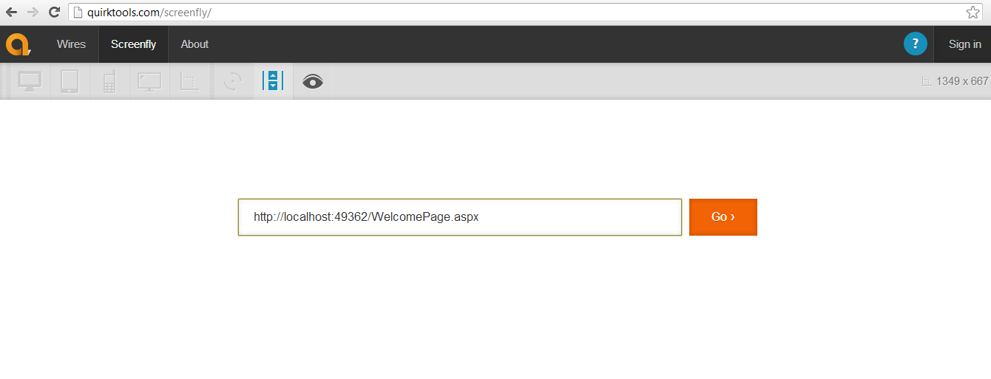**Figure-27: Emulator home screen**

The url on which our project is hosted should be provided then the emulator starts with the default desktop 17 inch desktop view as shown:

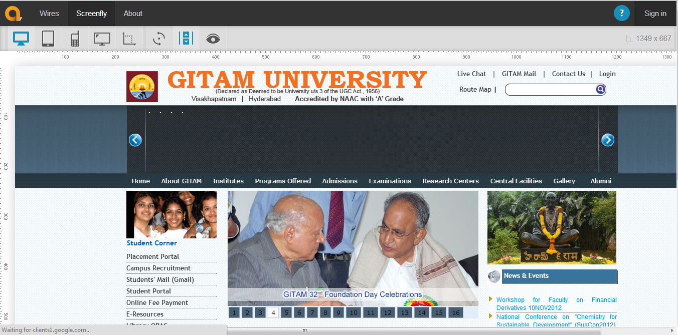

**Figure-28:Default desktop view**

**8.1.2 For 15inch notebook the following is the view:**

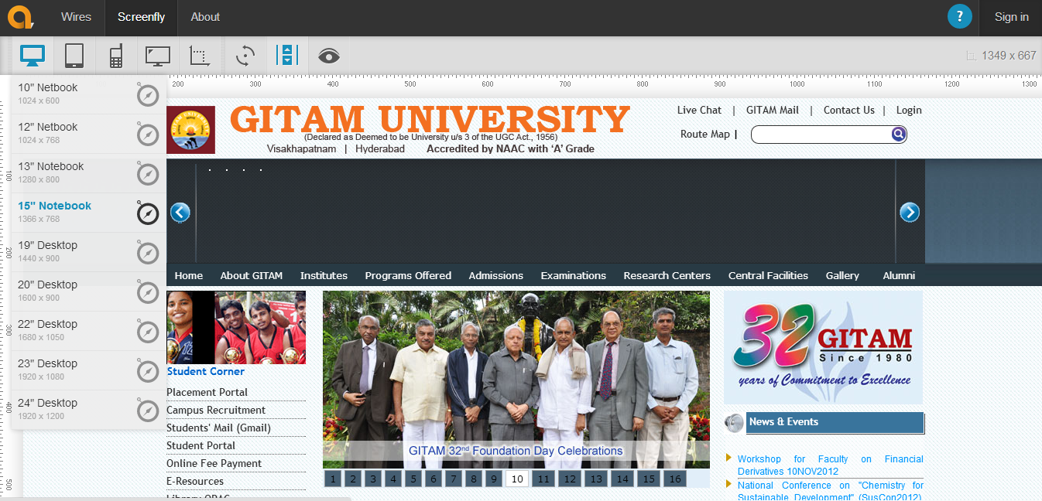

**Figure-29: For 15inch notebook**

**8.1.3 For 12 inch notebook the following is the view:**

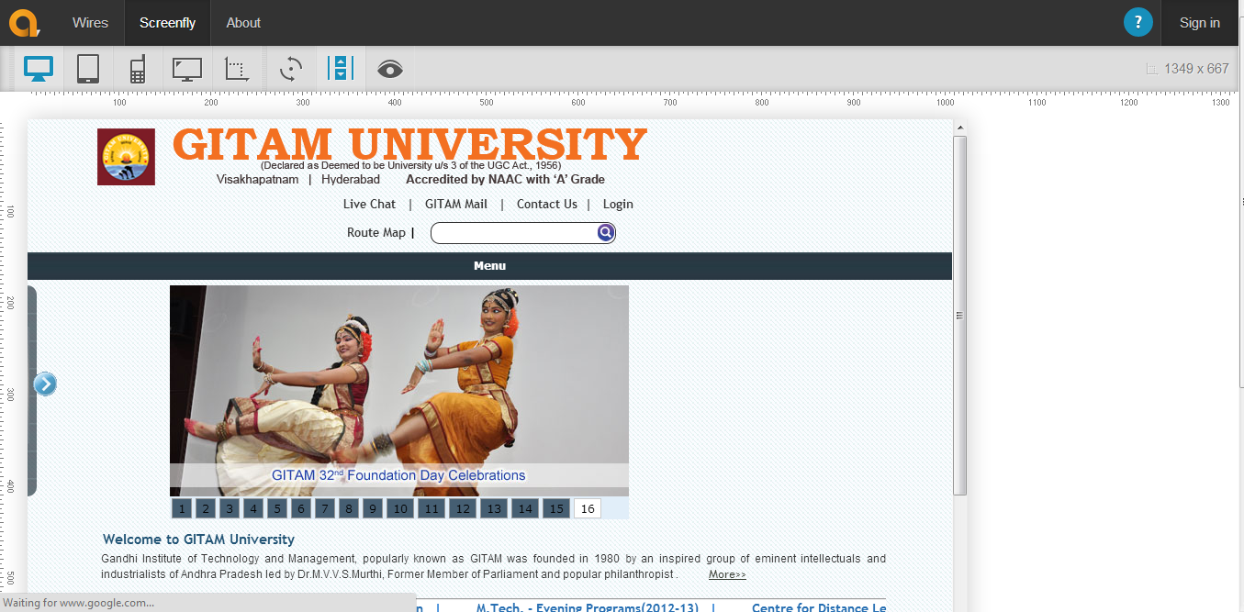

**Figure-30: For 12 inch notebook**

**8.1.4 For Kindle Fire HD 7 tablet the following is the view:**

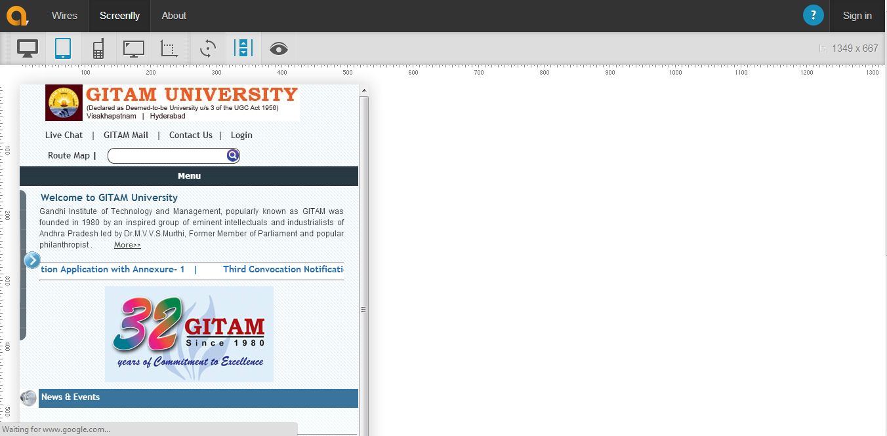

**Figure-31: For Kindle Fire HD 7 tablet**

**8.1.5 For Google Nexus the following is the view:**

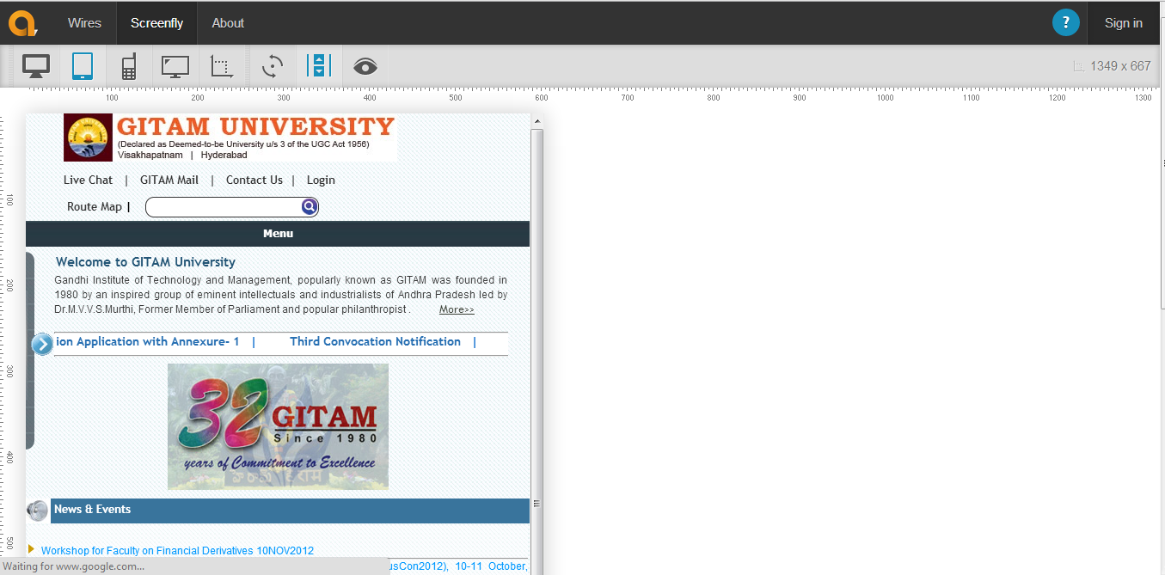

**Figure-32: For Google Nexus**

**8.1.6 For Apple Mini 1-3 the following is the view:**

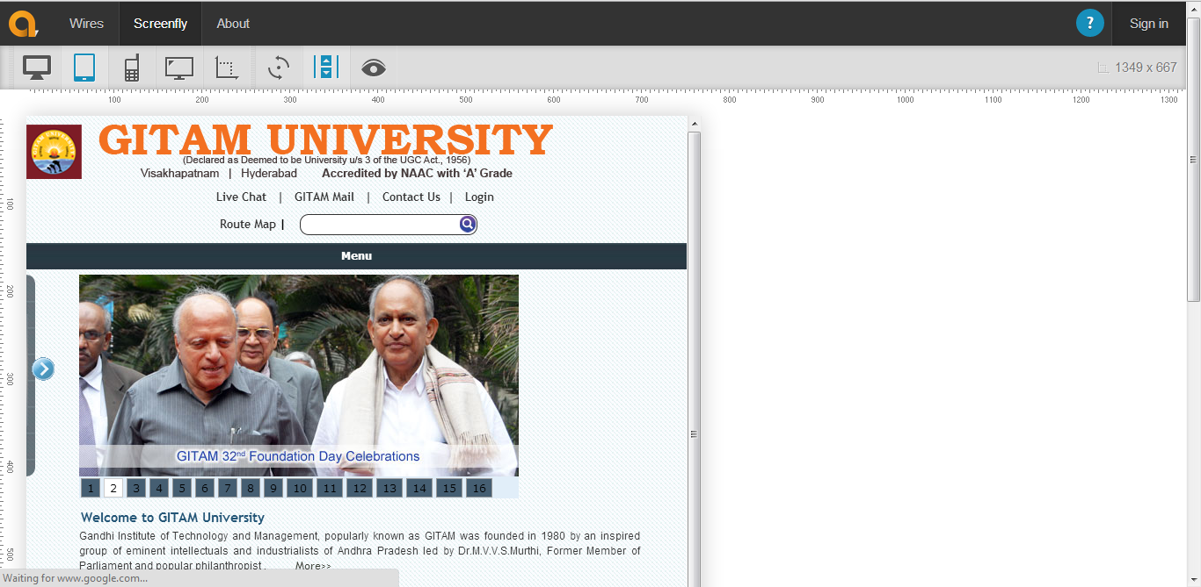

**Figure-33: For Apple Mini 1-3**

**8.1.7 For Apple Iphone-5 the following is the view:**

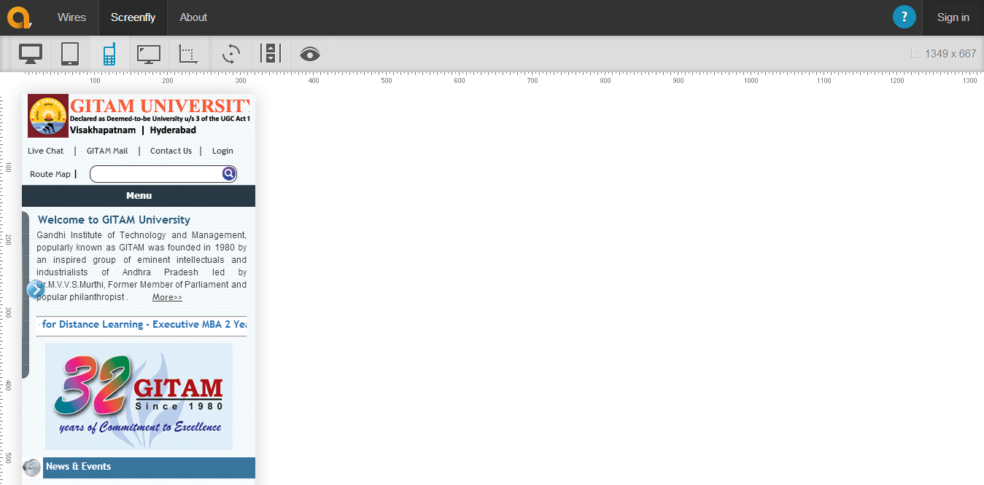

**Figure-34: For Apple Iphone-5**

**8.1.8 For Samsung S-3 the following is the view:**

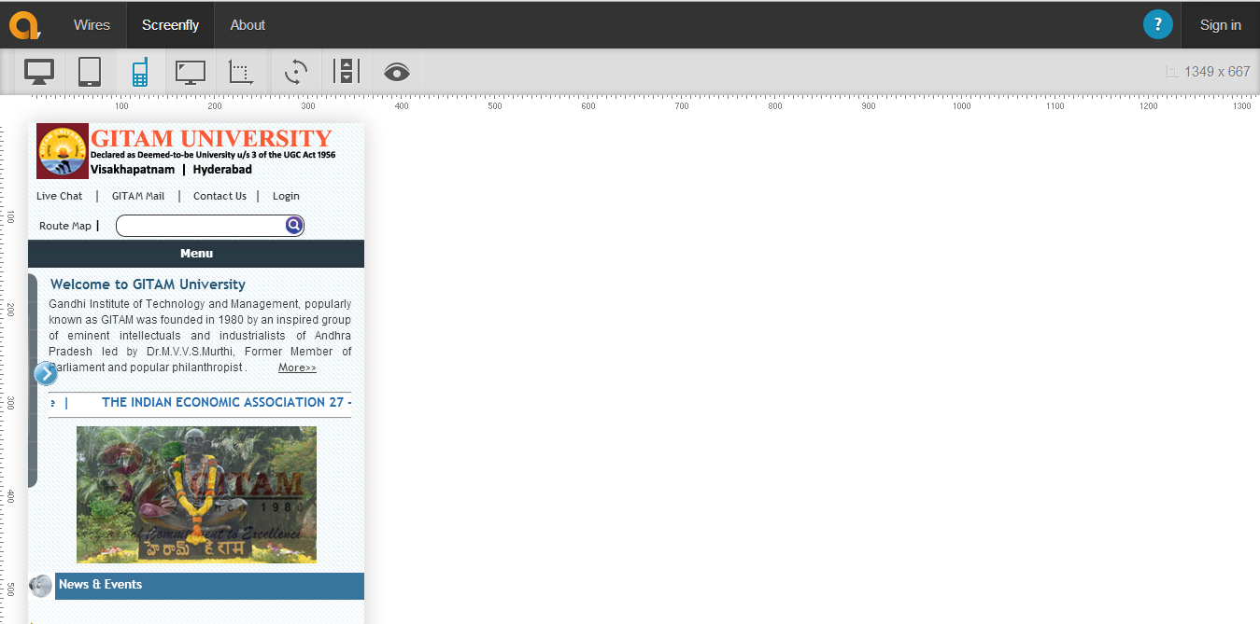

**Figure-35:For Samsung S-3**

**8.2 Device Testing**

The responsive Gitam university home page is tested on device **Samsung Galaxy note-1** and here is the way it looks

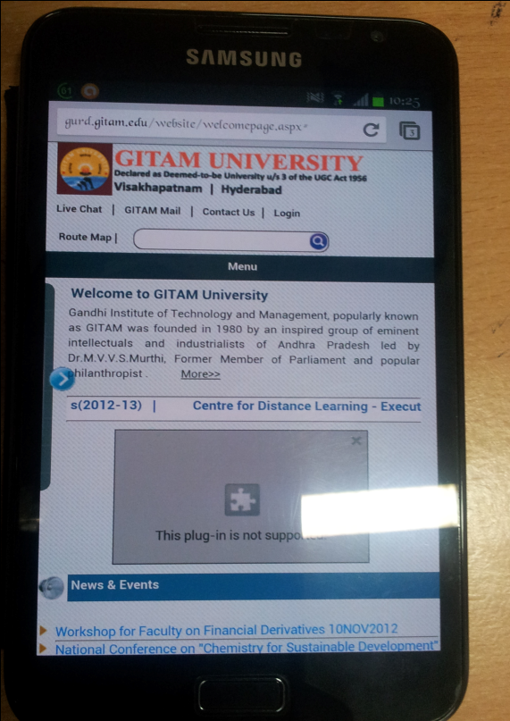

**Figure-36: Samsung Galaxy note-1 portrait view**

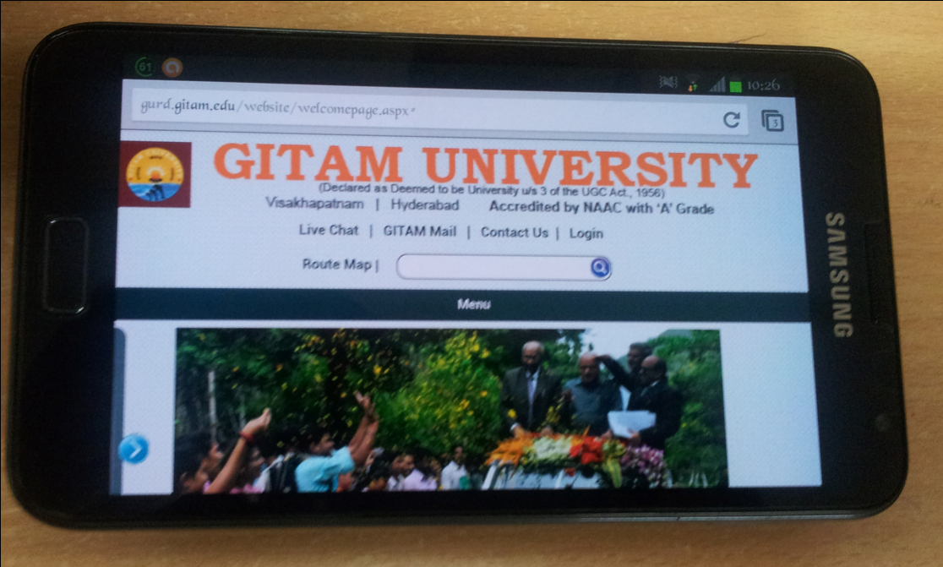

**Figure-37: Samsung Galaxy note-1 landscape view**

**9.0 Conclusions and future scope**

* **Responsive Web Design Power**: Responsive Web Design is an excellent alternative to create a single responsive website which automatically adapts to all internet supported devices to develop multiple websites for distinct devices. In bottom line, it eliminates the hassle of designing, developing and maintenance of separate website and hence save our time and money.
* **Flexibility to customers**: Responsive Web Design facilitates us to create a flexible and comprehensive user experience. In consequence, it enables to maintain website in a very easy and affable way and abandon the need to develop specific mobile version or device-specific site of our website.
* **Proven advantage of Responsive Web Design**: Responsive Web Design facilitates web-designers to create a website incorporating flexible images as well as flowing layouts which automatically accommodate with user's browser ensuring the website look, consistency, usability regardless of devices' screen size. However, it eliminates the necessity of creating website for distinct devices.

**10.0 References**

1. *Responsive Web Design with Html5 and Css3,* by Ben Frain, 2nd Edition.
2. *Implementing Responsive Design: Building sites for an anywhere, everywhere web,* by Tim Kadlec, 3rd Edition.
3. *Head First Mobile Web,* by Lyza Gardner and Jason Grigsby, 1st Edition.
4. [en.wikipedia.org/wiki/Responsive_Web_Design](http://en.wikipedia.org/wiki/Responsive_Web_Design).
5. www.abookapart.com/products/responsive-web-design
6. [mattkersley.com/responsive](http://mattkersley.com/responsive/)
7. [mediaqueri.es](http://mediaqueri.es)